**Unext Training Assignment**

**(17th JUNE 2022)**

NAME –ROHIT ARORA

ROLLNO – DXC-262AB-12009

BATCH – DXC-262-ANALYTICS-B12-AZURE

COMPANY – DXC TECHNOLOGY

EMPLOYEE DOMAIN – AZURE ANALYTICS

TRAINER NAME – MR. AJAY KUMAR

DATE OF SUBMISSION – 17th JUNE 2022

NO. OF QUESTIONS: 8

1. Write a python program to predict car sales of a company by using the below data.

Year :2010 2011 2012 2013 2014 2015 2016 2017 2018 2019 2020

Sales in Millions :169 199 262 301 345 398 501 595 610 700 720

Display the outcome using linear regression method.

Code for deploying it:

import matplotlib.pyplot as plt

import numpy as np

from sklearn import linear_model

year = [2010,2011,2012,2013,2014,2015,2016,2017,2018,2019,2020]

sales = [169 , 199 , 262 , 301, 345 , 398 , 501, 595, 610 , 700 , 720]

print(sales)

new_sales = np.array(sales).reshape((-1,1))

print(new_sales)

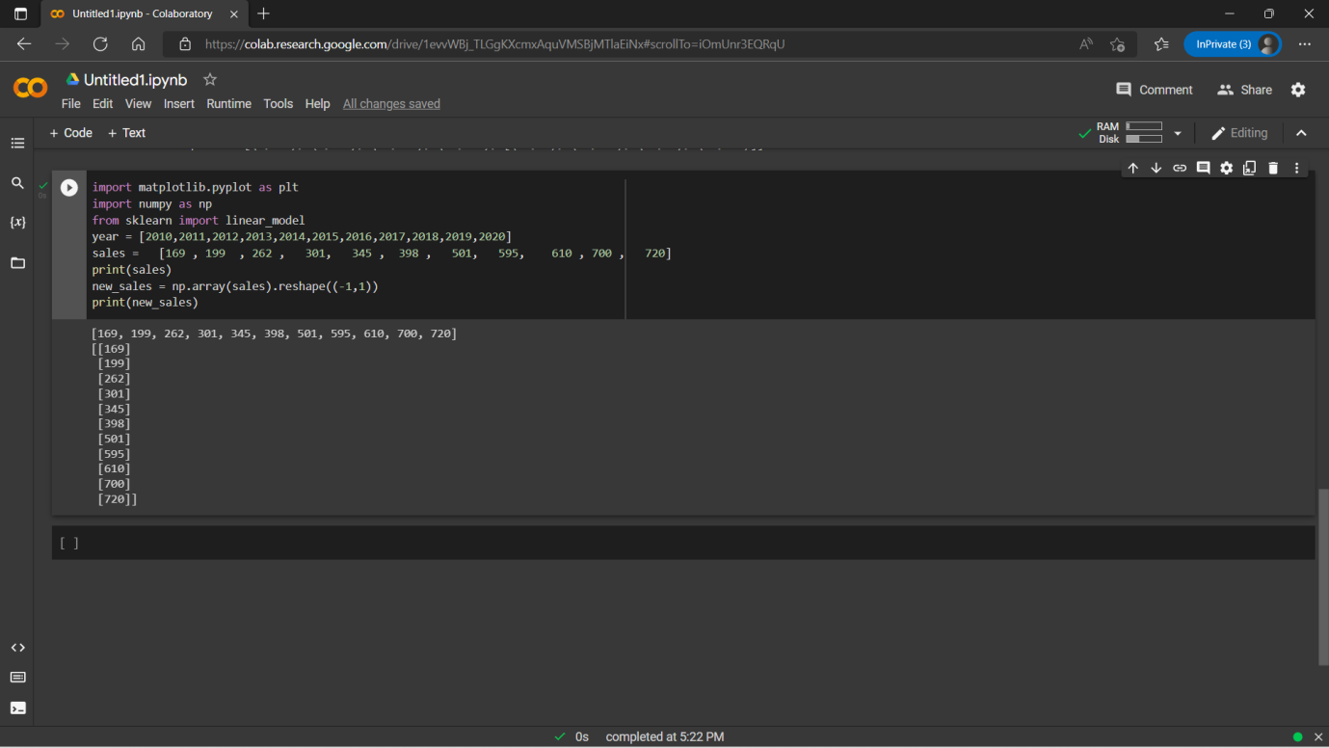

reg_model=linear_model.LinearRegression()

reg_model.fit(new_sales,year)

print("Coefficient : ",reg_model.coef_)

print("Intercept : ", reg_model.intercept_)

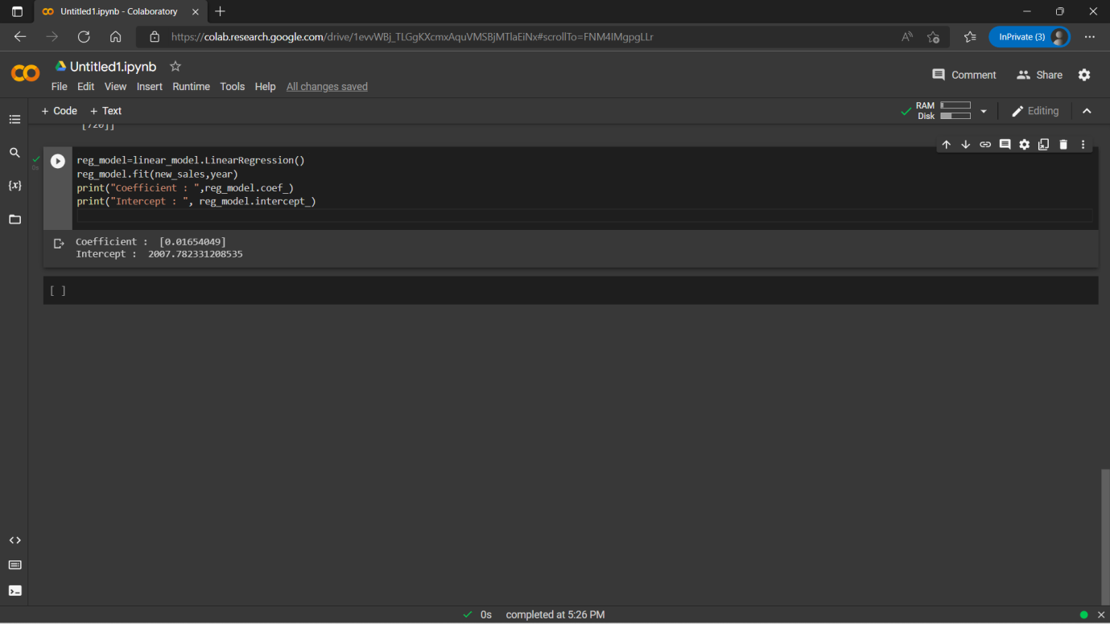

def graph(formula,x_range):

x=np.array(x_range)

y=eval(formula)

plt.plot(x,y)

graph('reg_model.coef_*x+reg_model.intercept_',range(100,1000))

plt.scatter(new_sales,year,color='purple')

plt.ylabel("Year")

plt.xlabel("Sales in Million")

plt.show()

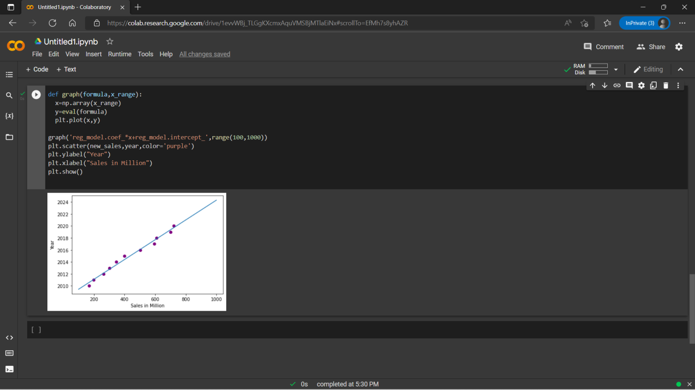

2. Write a python program to generate possible tuples from any two sample lists.

Code for deploying it:

test_tuple1 = (9,23)

test_tuple2 = (19,13)

print("The original Tuple 1 is : "+str(test_tuple1))

print("The original Tuple 2 is : "+str(test_tuple2))

res = [(a,b) for a in test_tuple1 for b in test_tuple2]

res = res + [[(a,b) for a in test_tuple2 for b in test_tuple1]]

print ("The Filtered Tuple is :" +str(res))

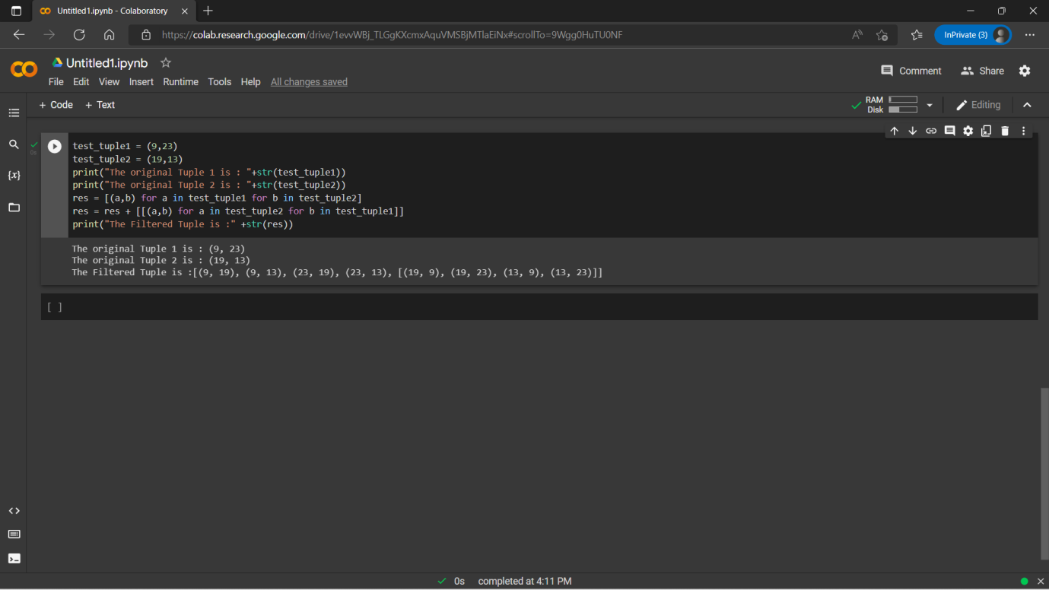

3. Create Azure Databricks and try to connect Databricks and power BI, explain the steps with screenshots.

**Step 1**: Create Azure Databricks by selecting the Databricks option by searching it.

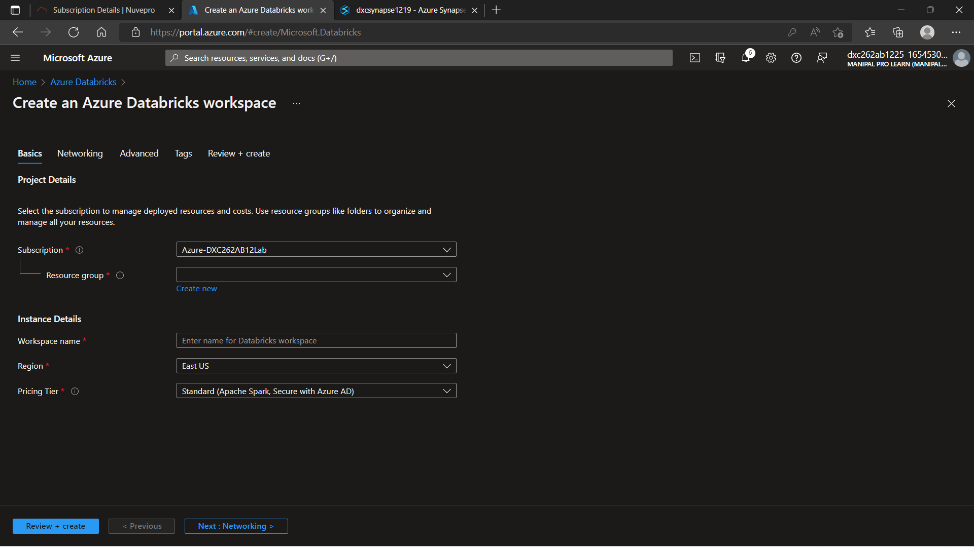

Fill in all the necessary details and click on **Review + Create.**

When the validation completes, click on create and wait for the deployment process to finish.

**Step 2:** After the deployment is completed, click on **Go To Resource**.

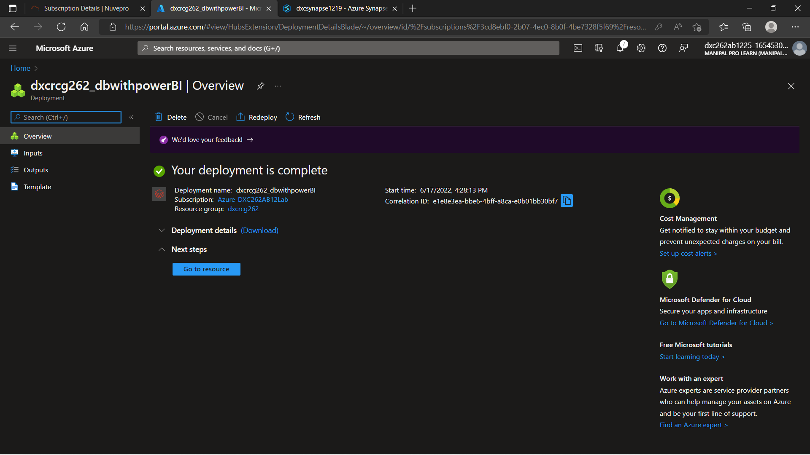

**Step 3:** After launching the workspace, first create a cluster.

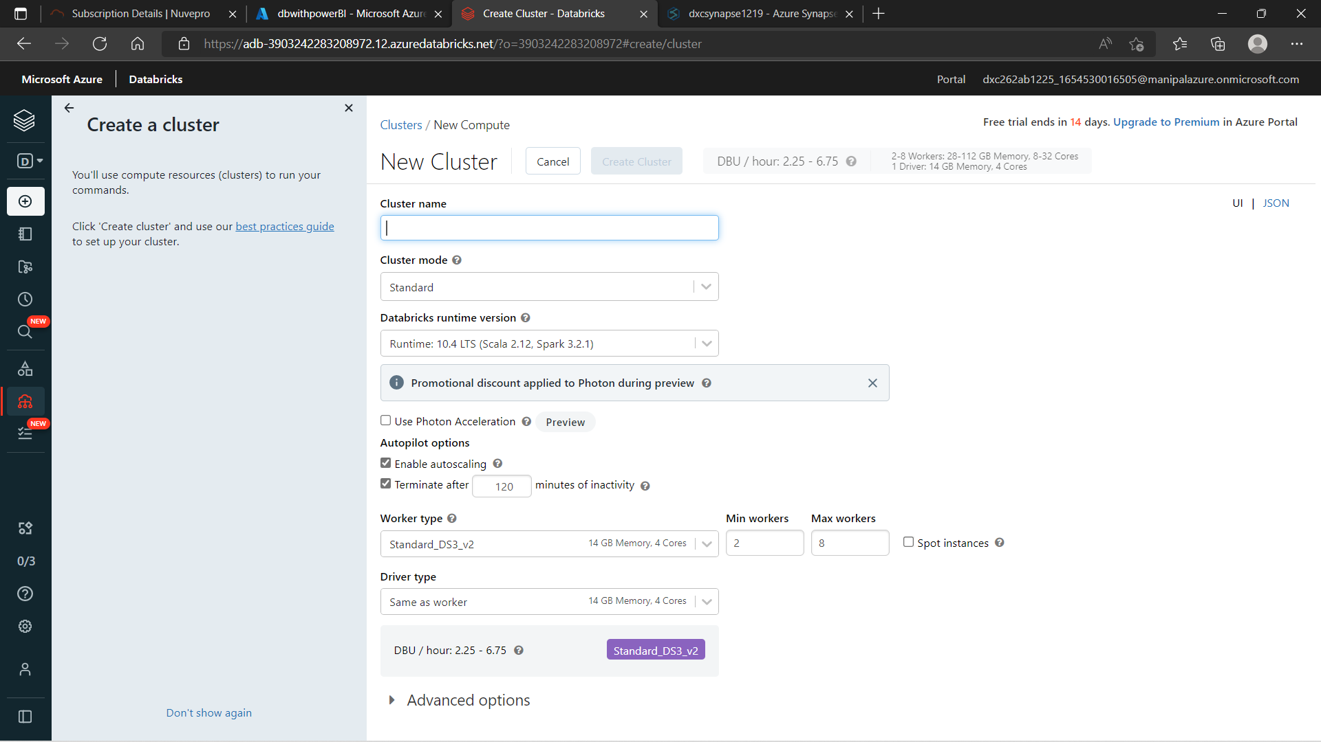

**Step 4:**  Then, create a notebook for computing any code that we need to perform and link it to the previous created cluster.

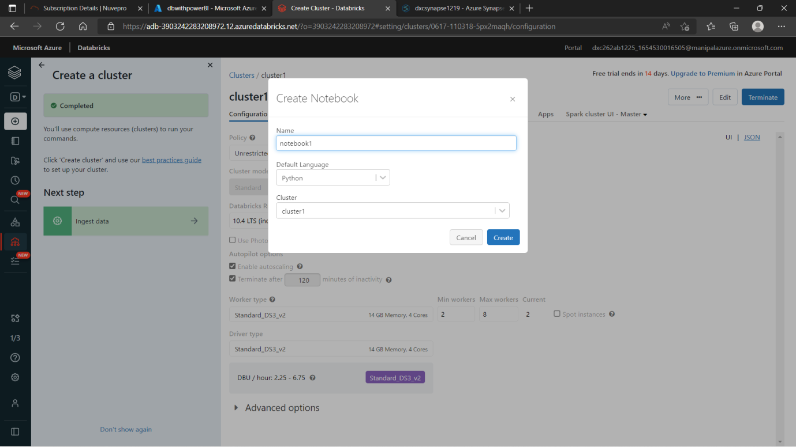

**Step 5:** Now, we need to create a table. While creating this table, we need to click on Partner Connect option to connect it with Power BI.

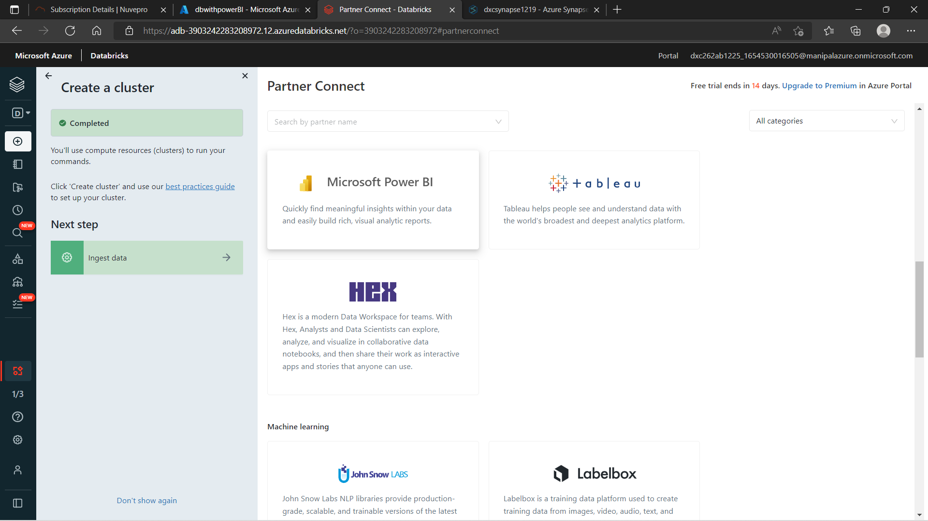

**Step 6:** Download the connection file and then use it. We need to generate and access token. For that, click on User settings and generate an access token.

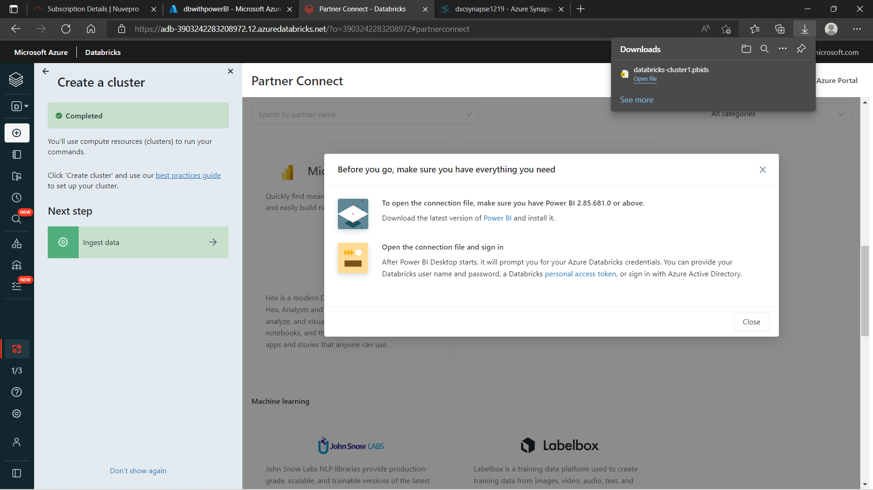

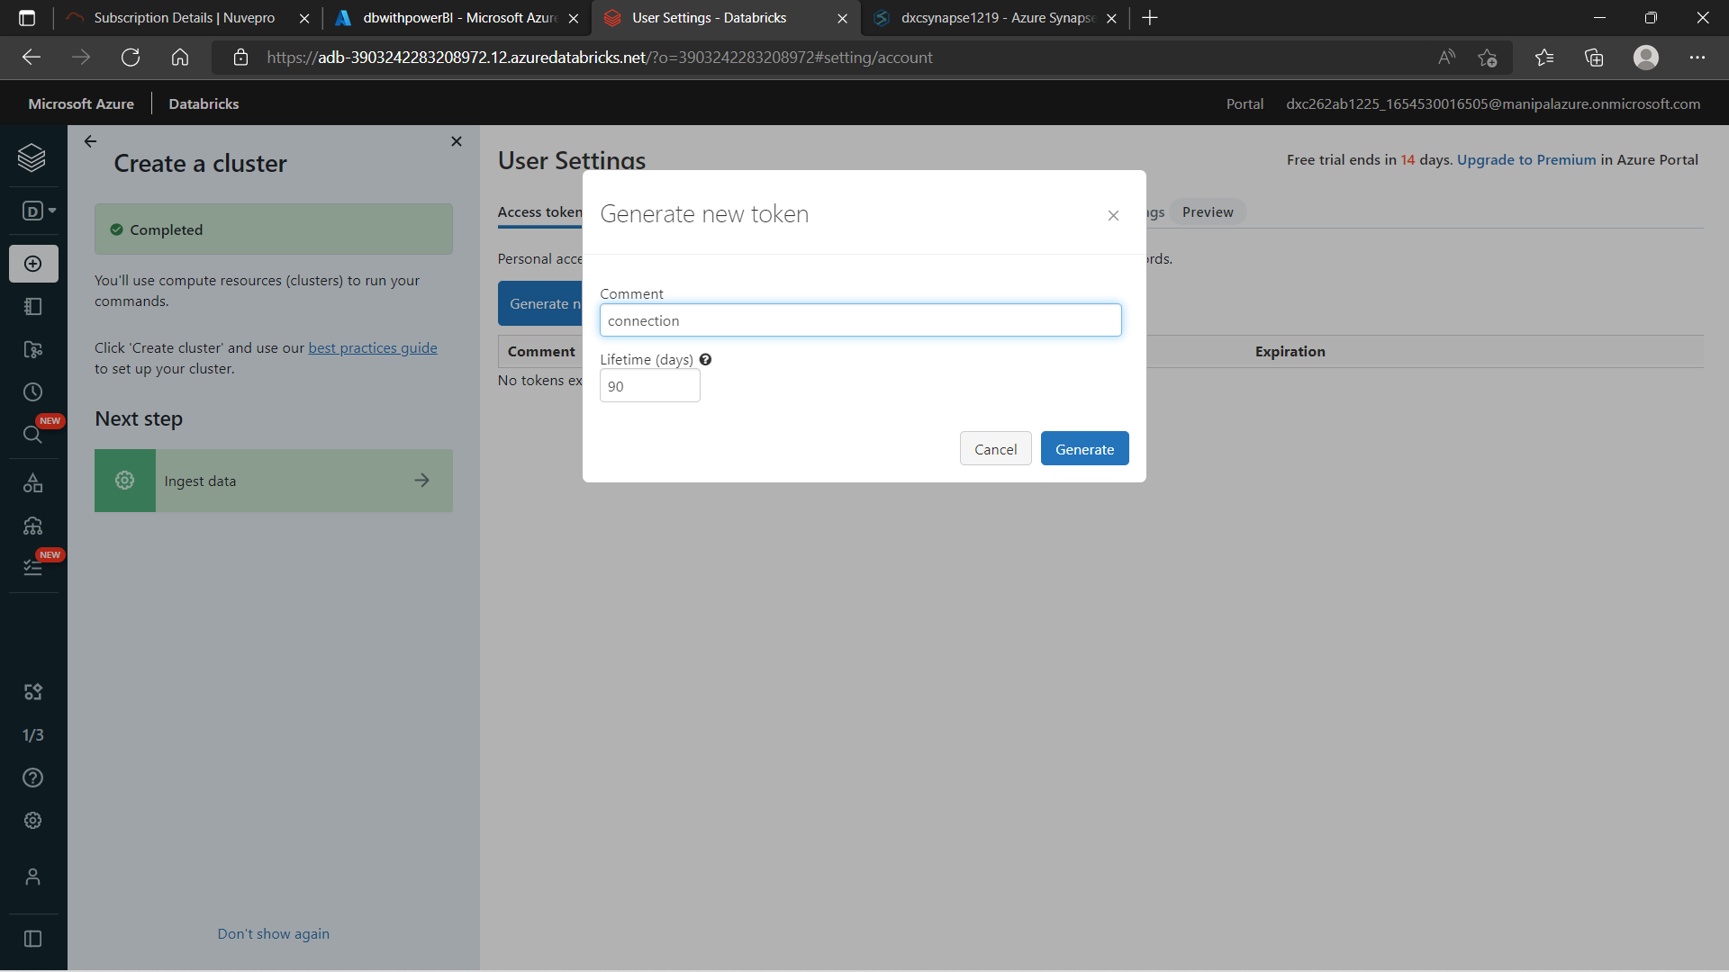

Copy the token code and save it for future use.

**Step 7:** Open the connection file and login using the access token. Now, you can load the data and perform analytics on it. We can plot and verify the data and present it in different formats.

4. Create Azure Synapse and connect with Azure Blob, explain the steps with screenshots

Azure Synapse and Azure blob storage can be integrated in order to copy data from one directory to another and to automate this process too. Follow the steps below in order to link both the services.

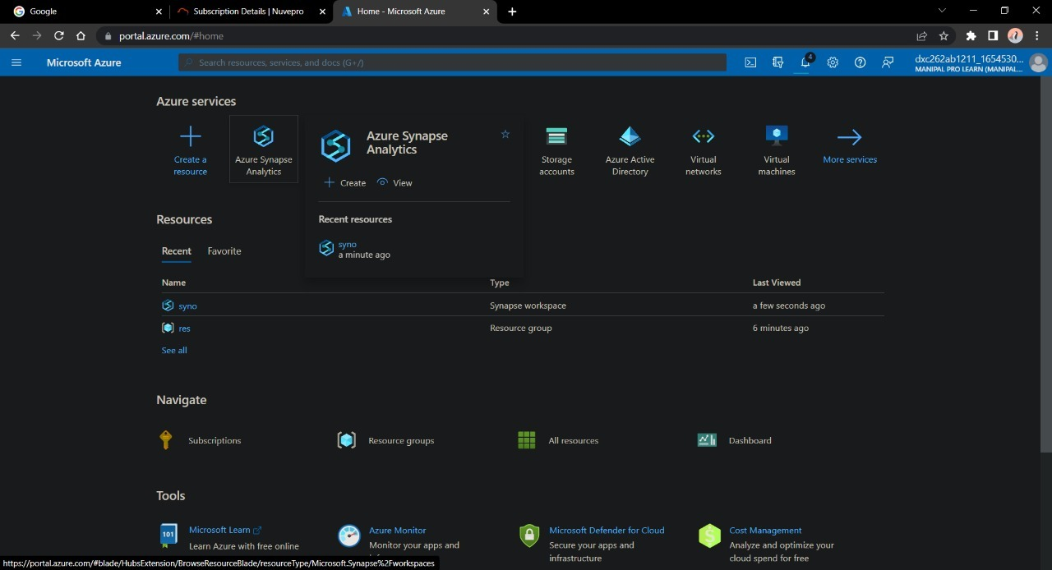

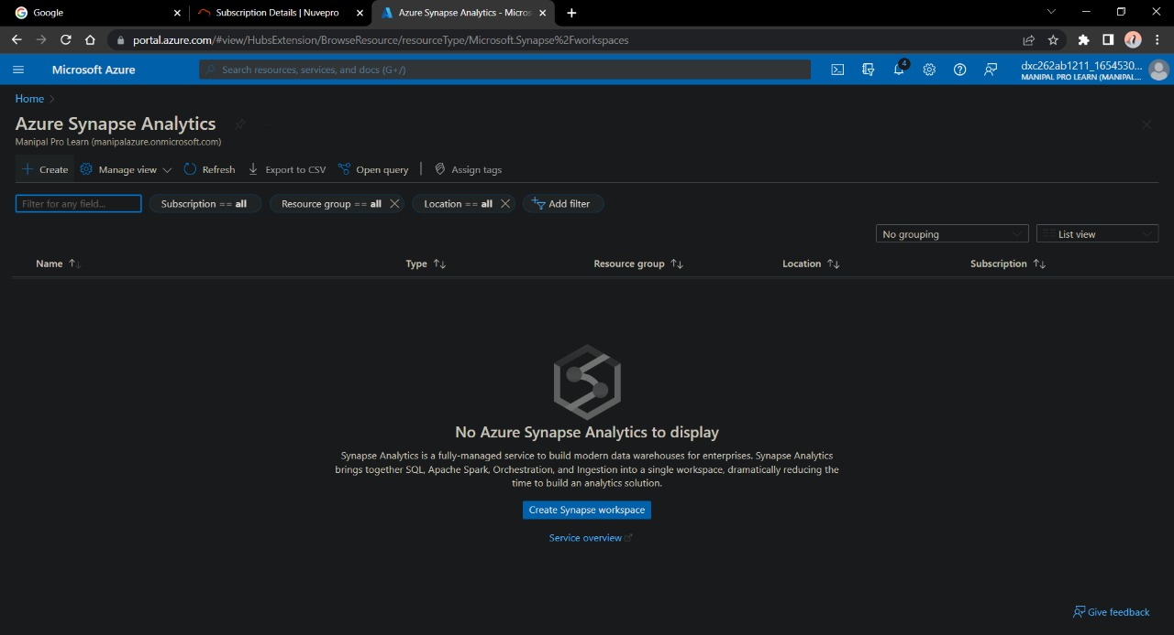

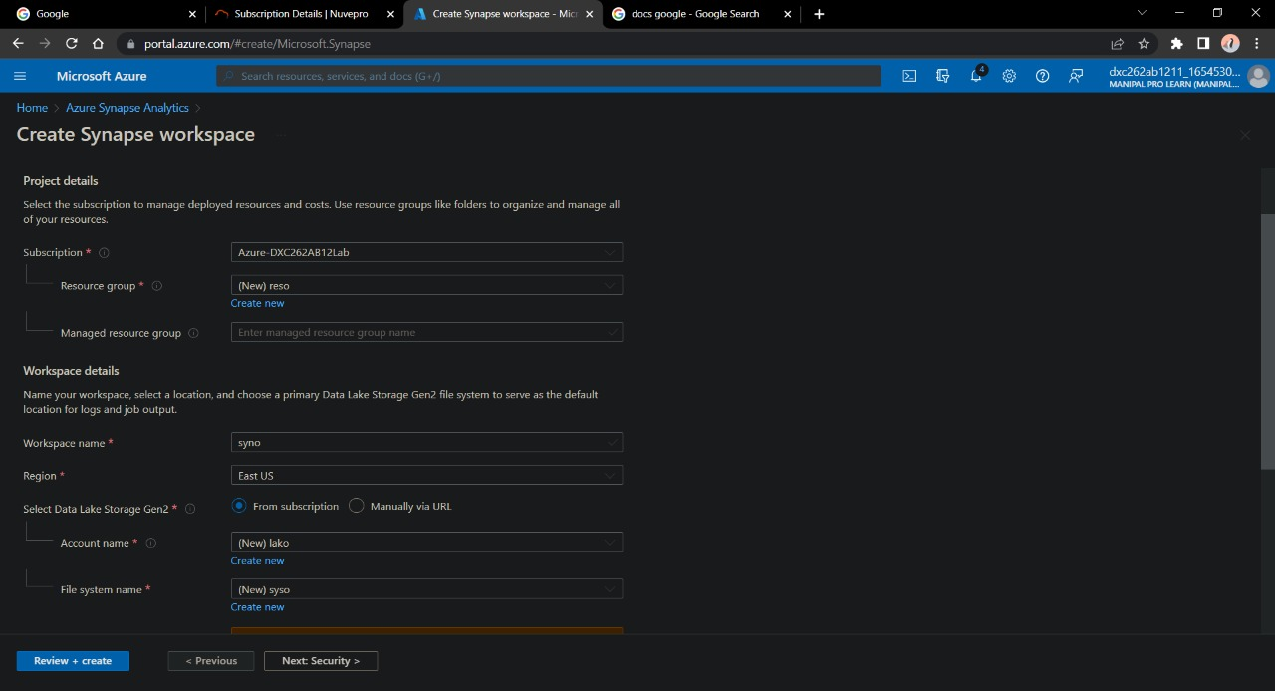

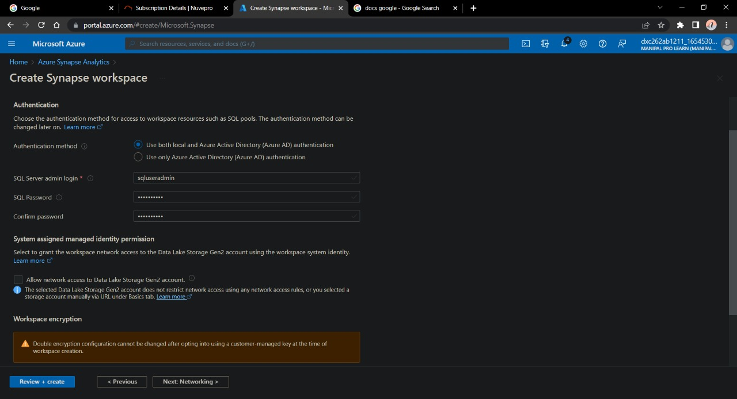

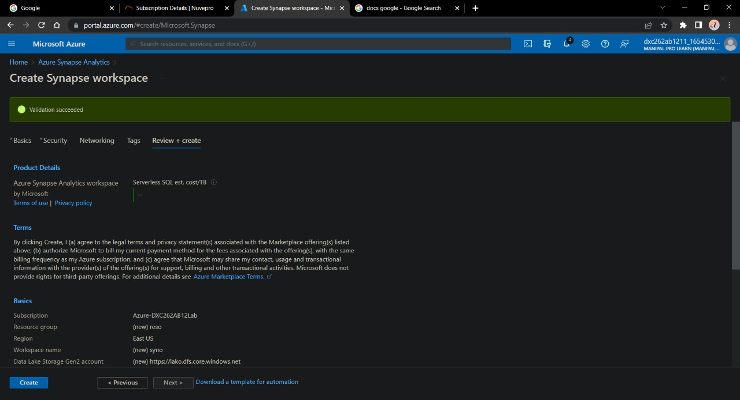

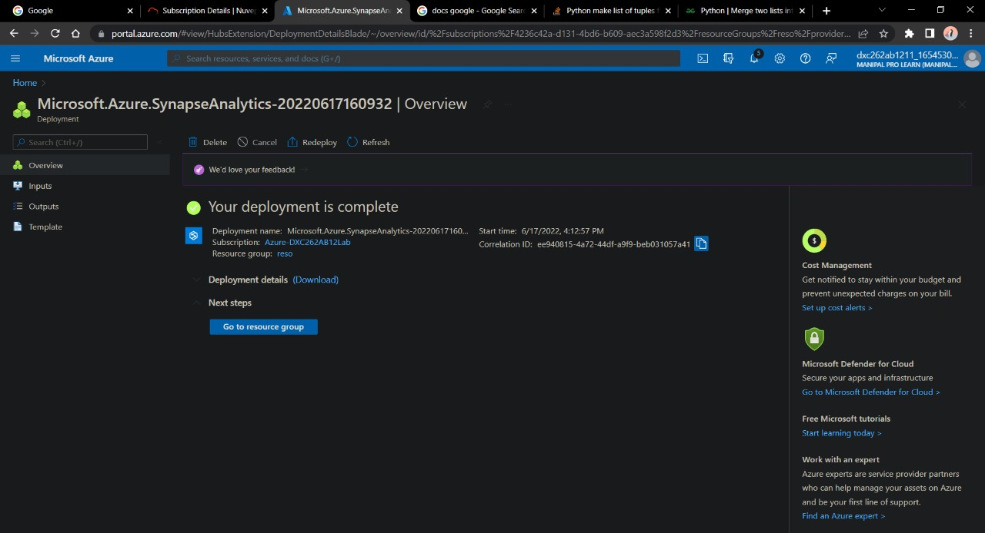

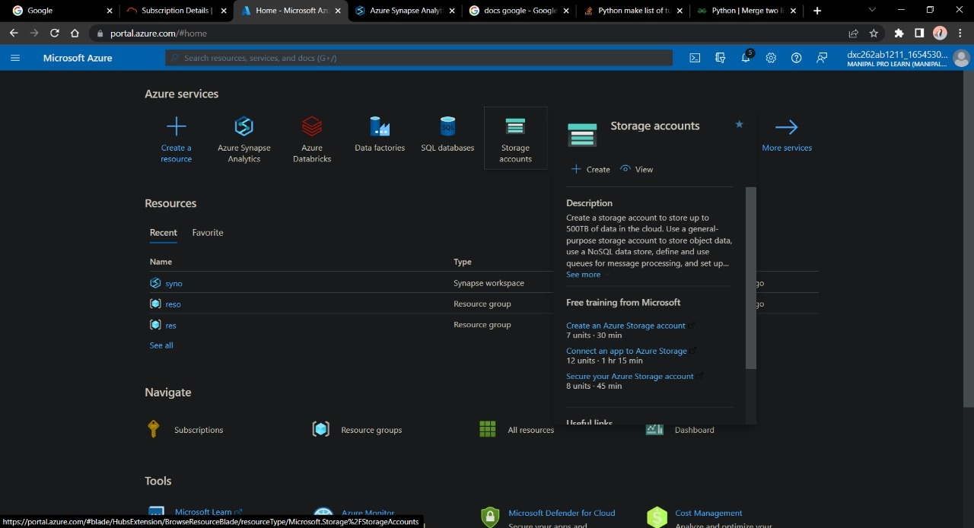

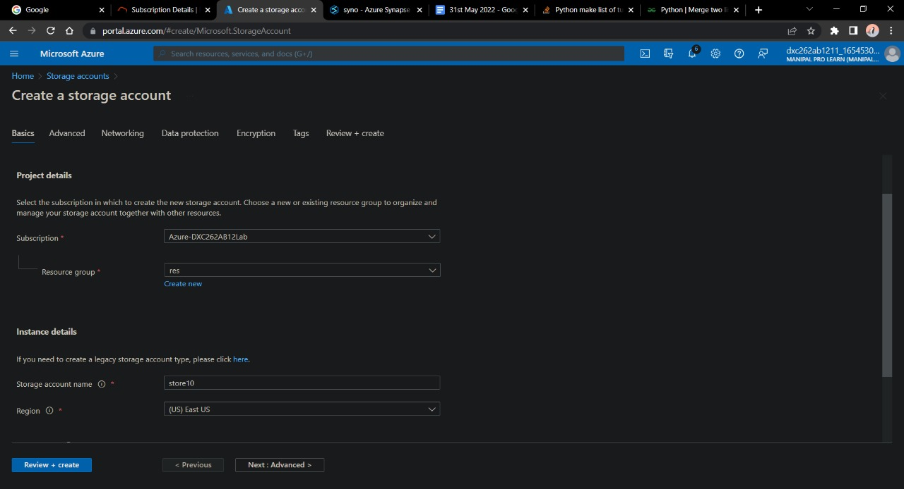

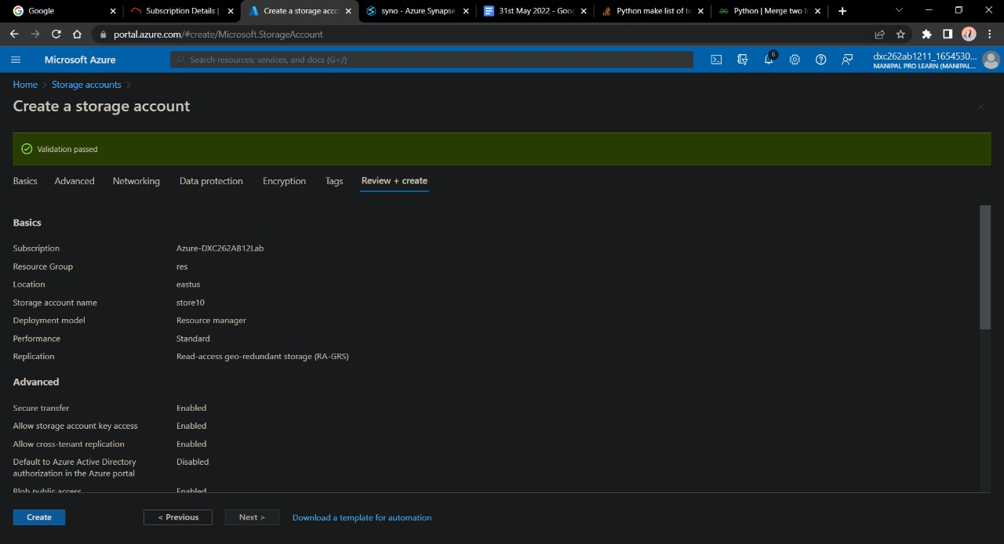

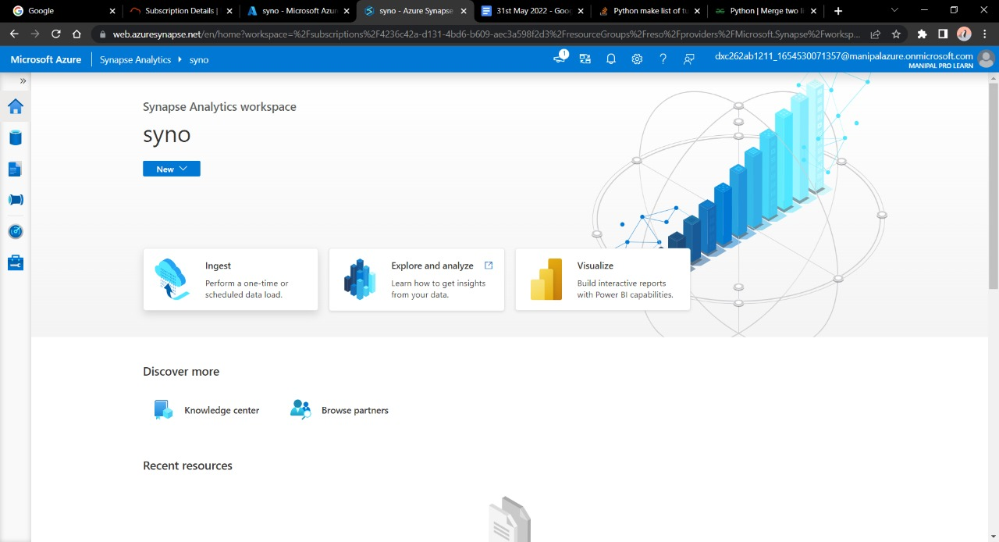

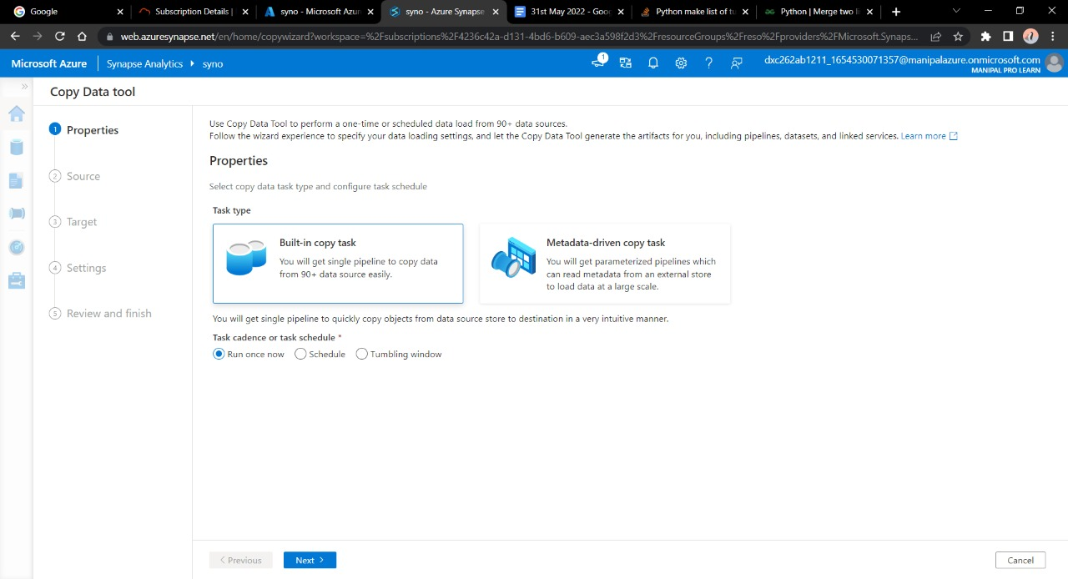

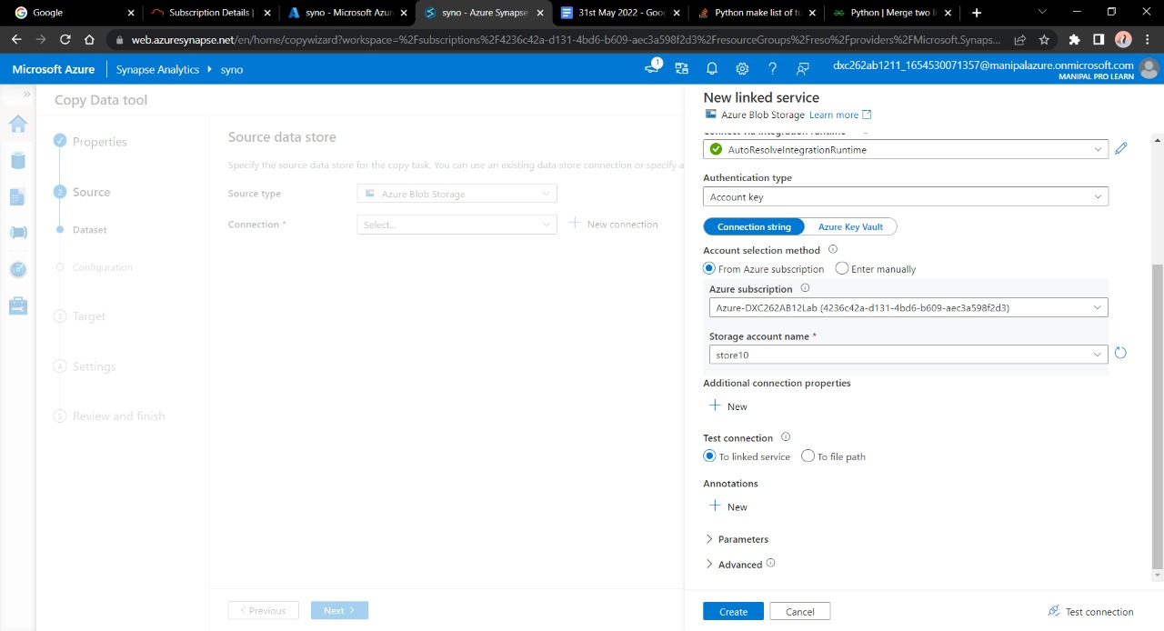

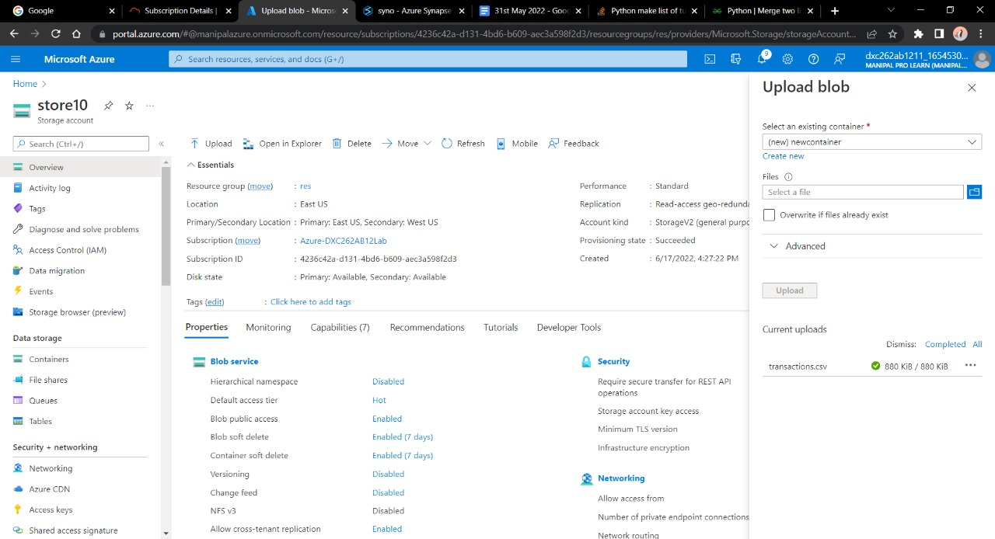

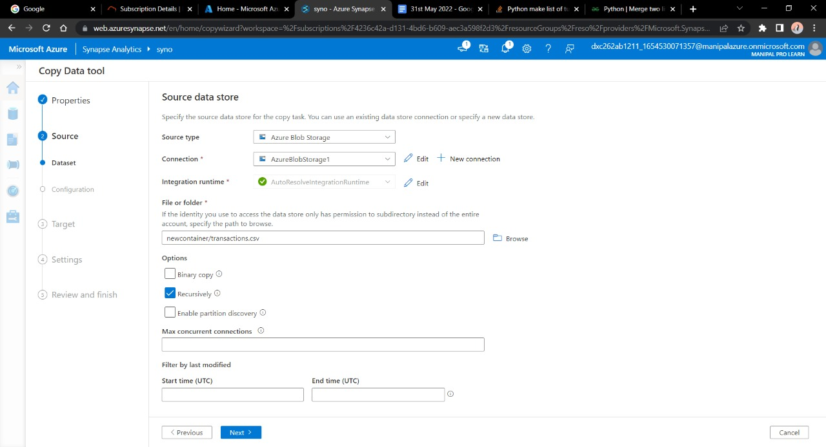

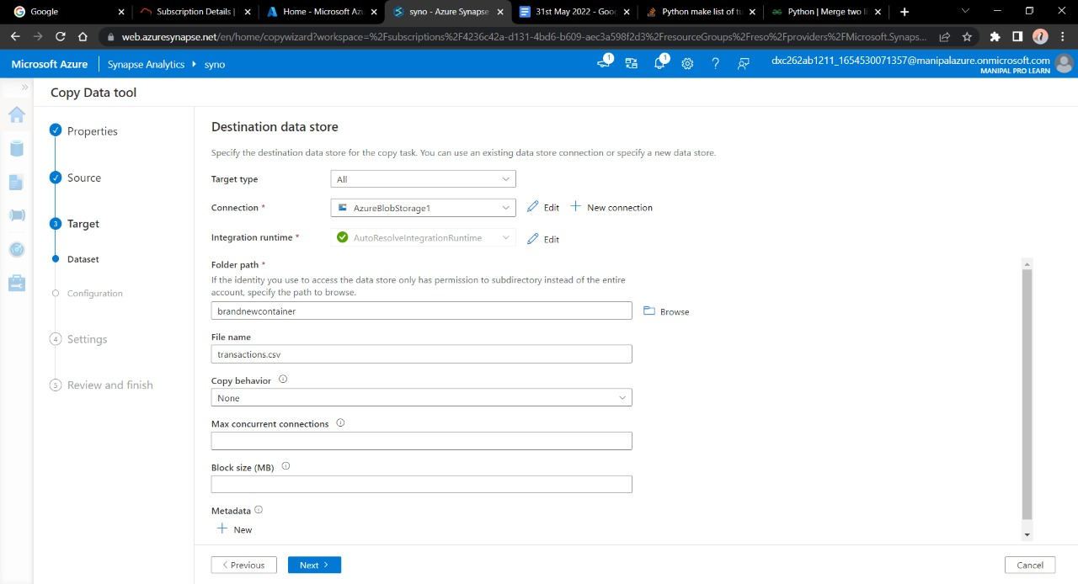

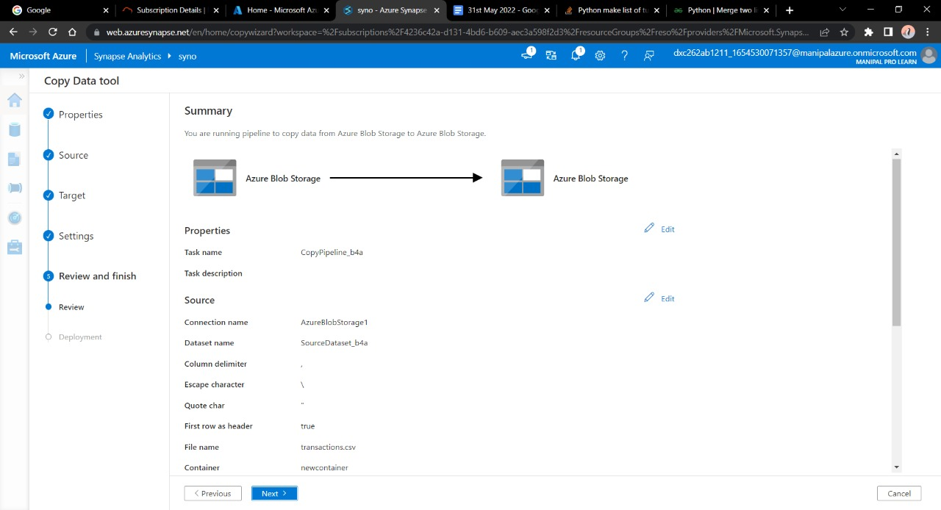

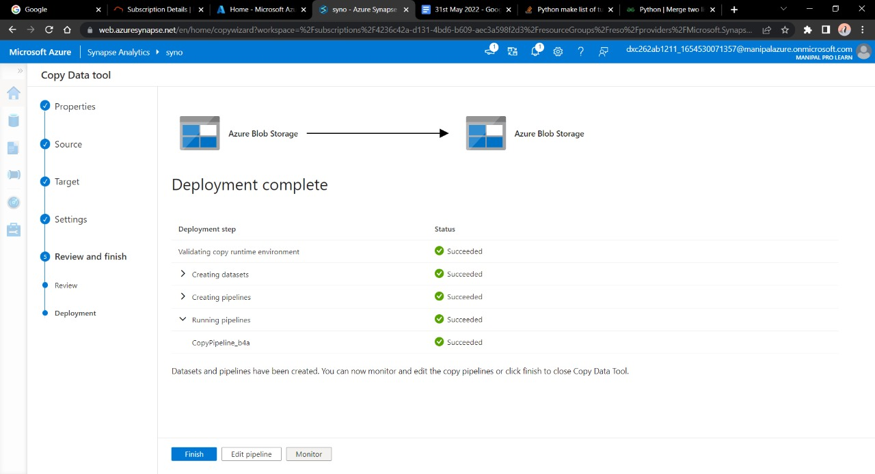

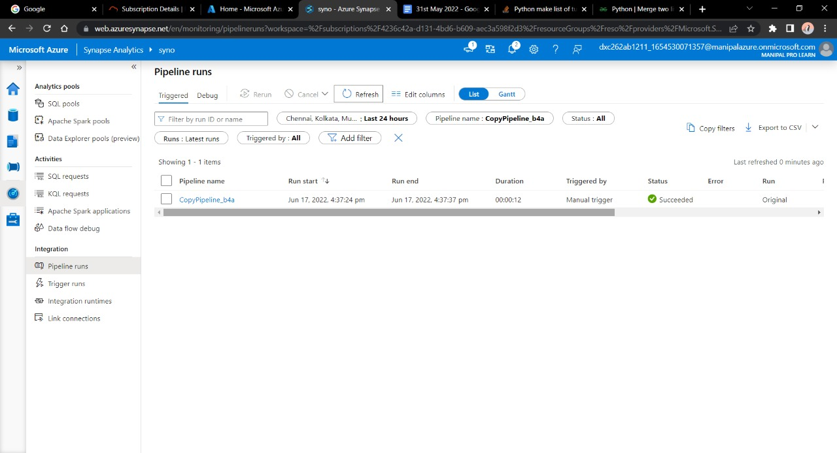

Here we have successfully triggered a pipeline that will copy the content of the newcontainer into the brand-new container.

5. Create Azure Synapse Spark pool and query sample JSON file, Explain the steps with screenshots.

**Step 1:** Fill in all the details required for creating the Azure Cosmos DB and click on **Review + Create**.

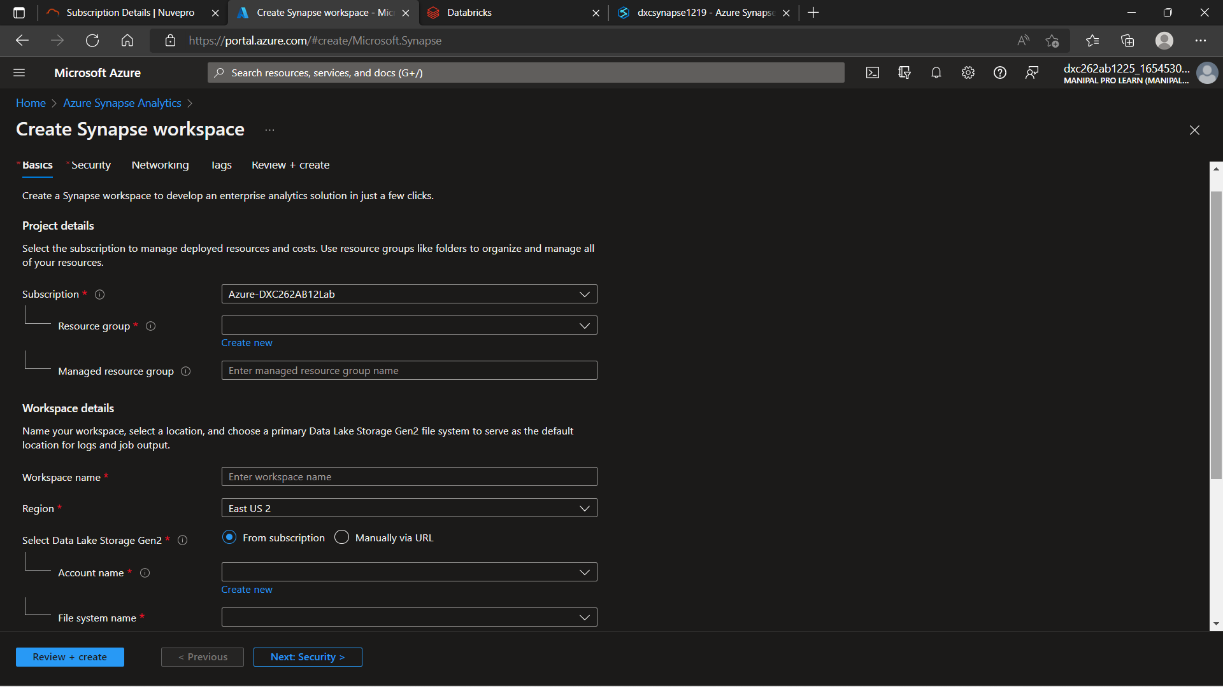

**Step 2:**  After the deployment is finished, click on Go To Resource.

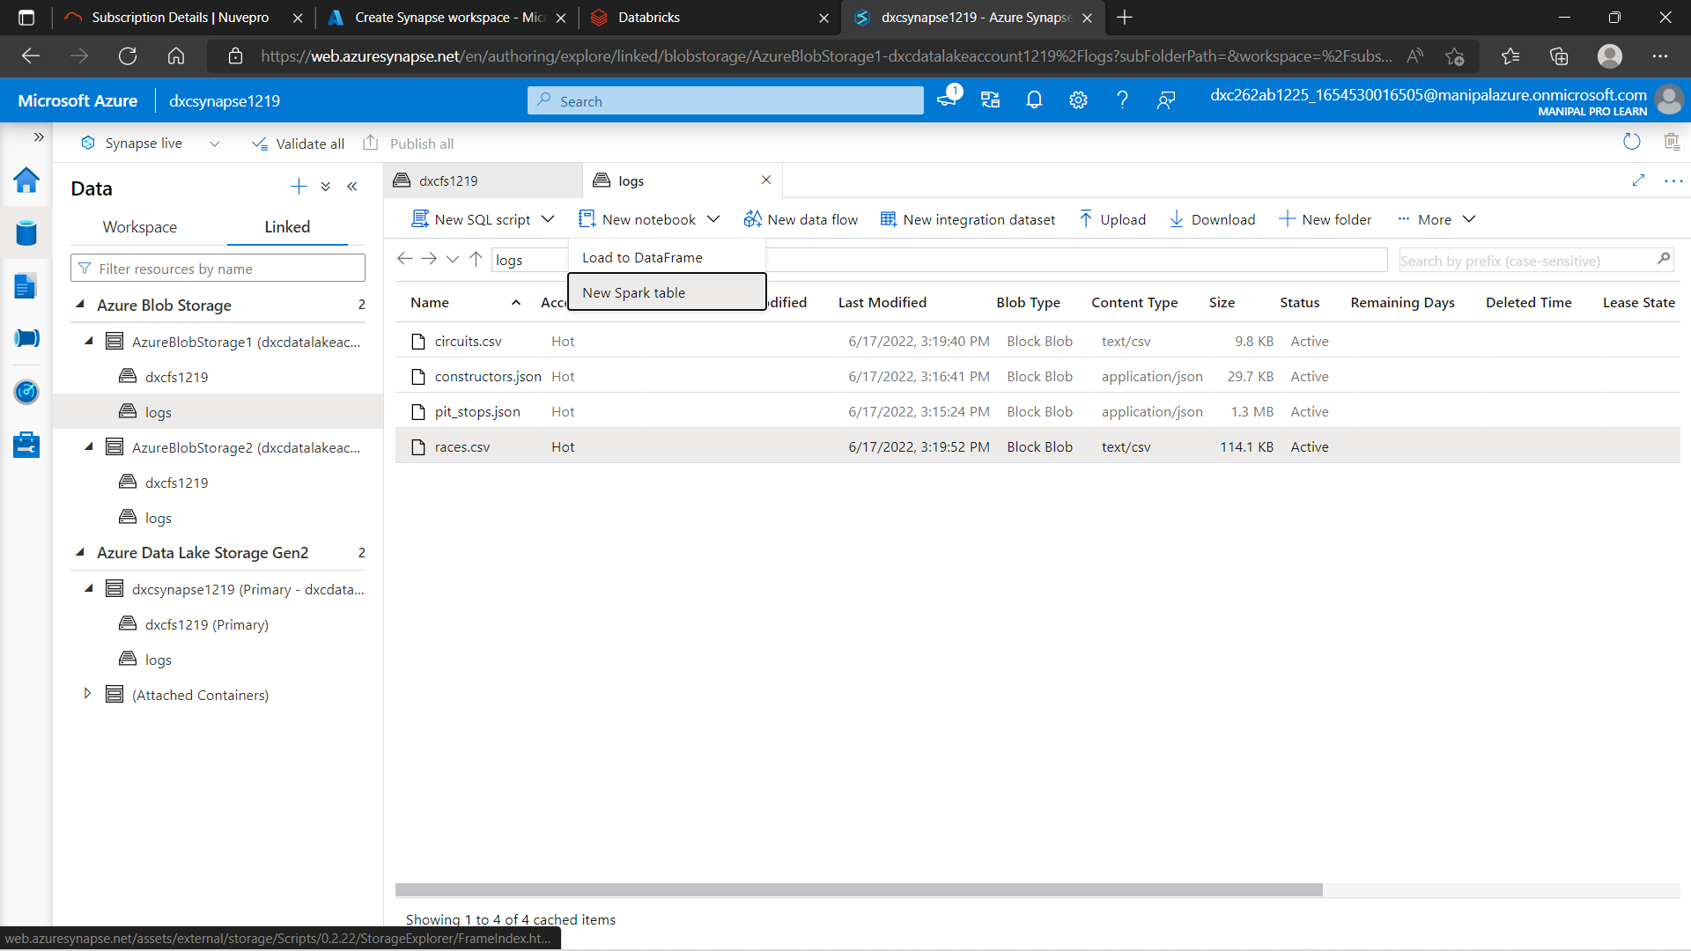

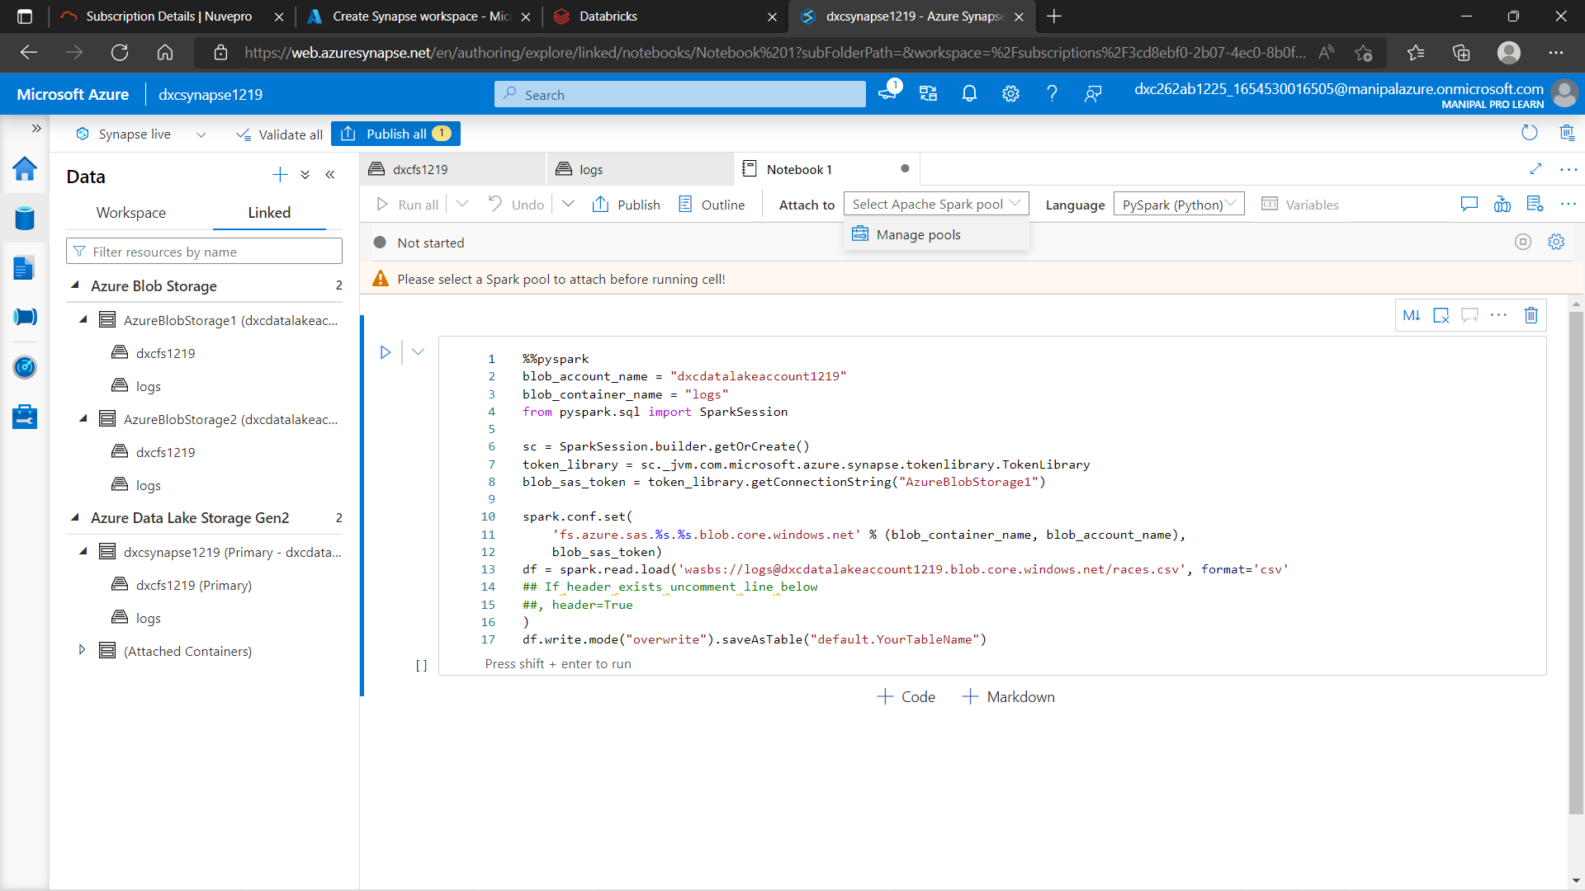

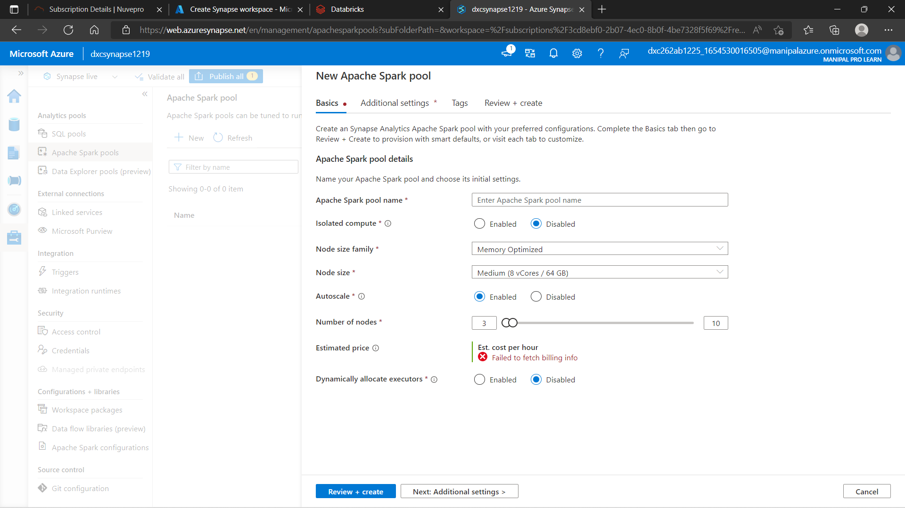

%%pyspark

blob_account_name = "dxcdatalakeaccount1219"

blob_container_name = "logs"

from pyspark.sql import SparkSession

sc = SparkSession.builder.getOrCreate()

token_library = sc._jvm.com.microsoft.azure.synapse.tokenlibrary.TokenLibrary

blob_sas_token = token_library.getConnectionString("AzureBlobStorage1")

spark.conf.set(

'fs.azure.sas.%s.%s.blob.core.windows.net' % (blob_container_name, blob_account_name),

blob_sas_token)

df = spark.read.load('wasbs://logs@dxcdatalakeaccount1219.blob.core.windows.net/races.csv', format='csv'

## If header exists uncomment line below

##, header=True

)

df.write.mode("overwrite").saveAsTable("default.races.csv")

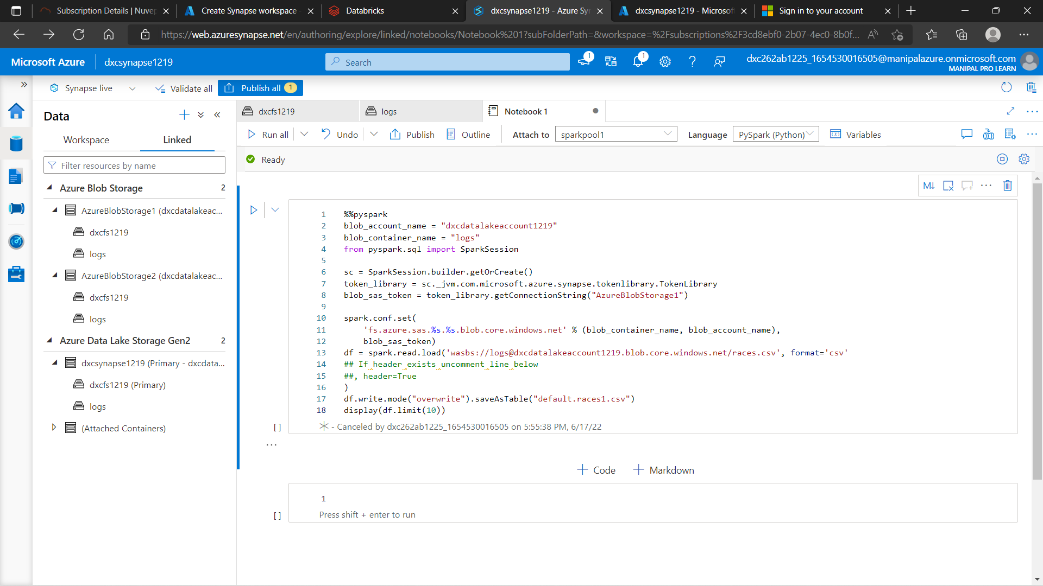

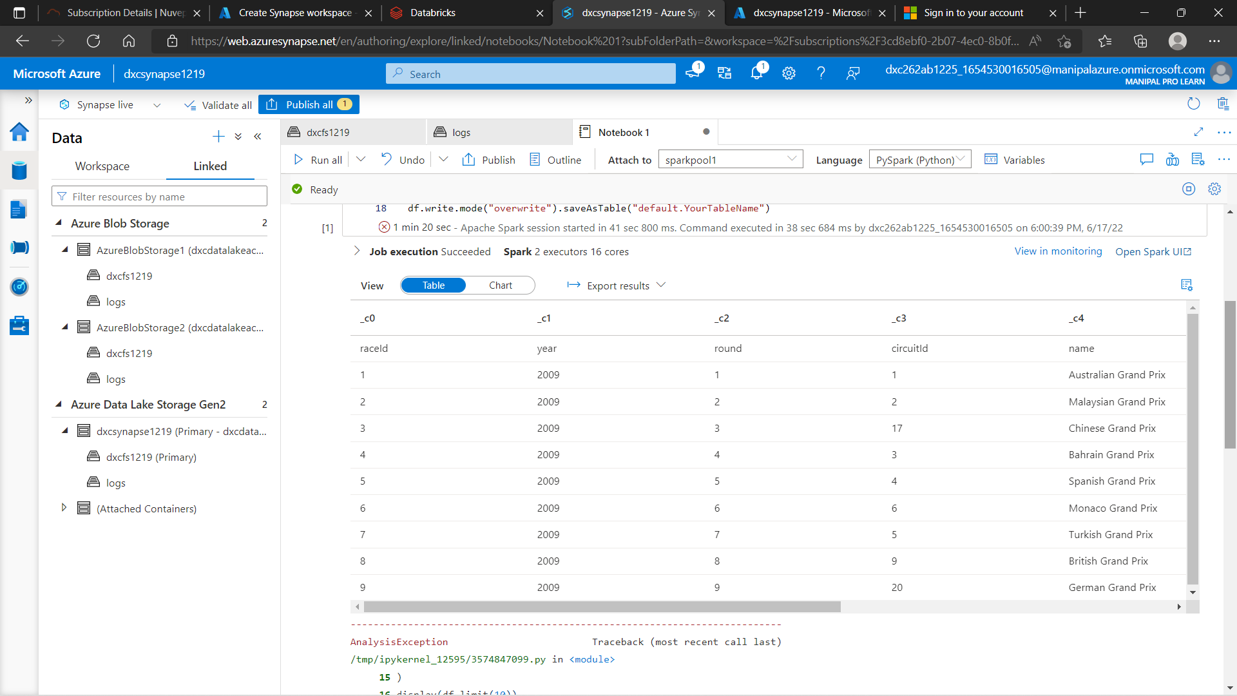

6.Create Azure Cosmos DB & import sample JSON file, explain the steps with screenshots

Cosmos DB can be used to store all kind of data including the Unstructured and semi-structured data i.e JSON data. Follow the steps in order to create a Cosmos DB account and upload JSON data into it.

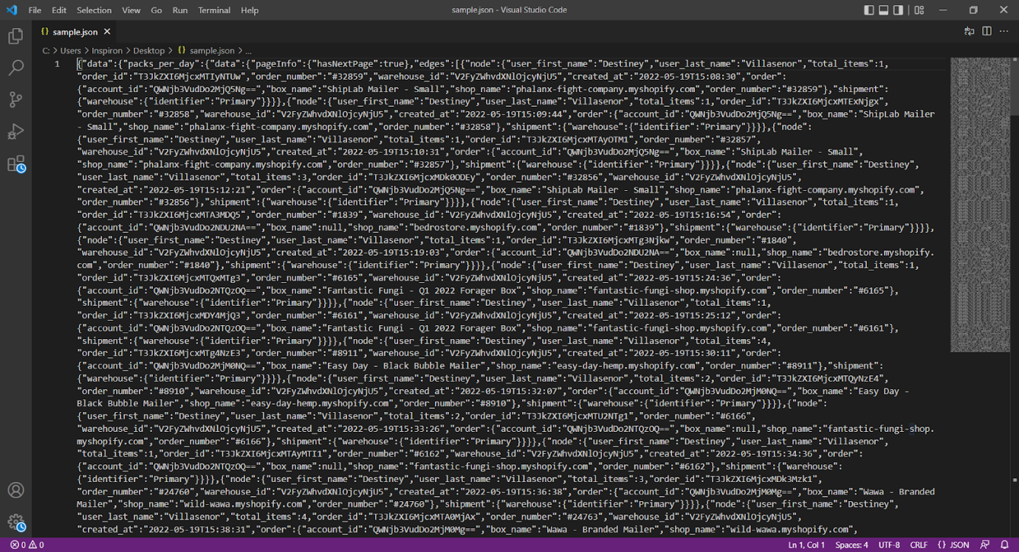

 Sample JSON file to upload

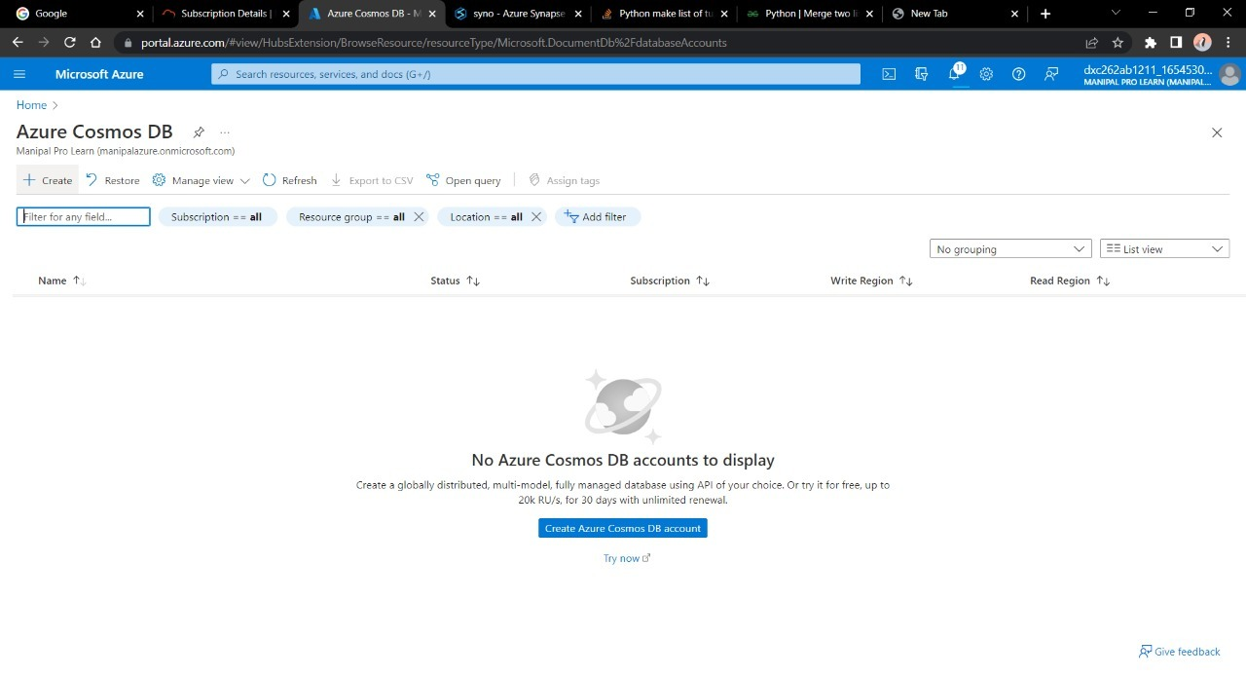

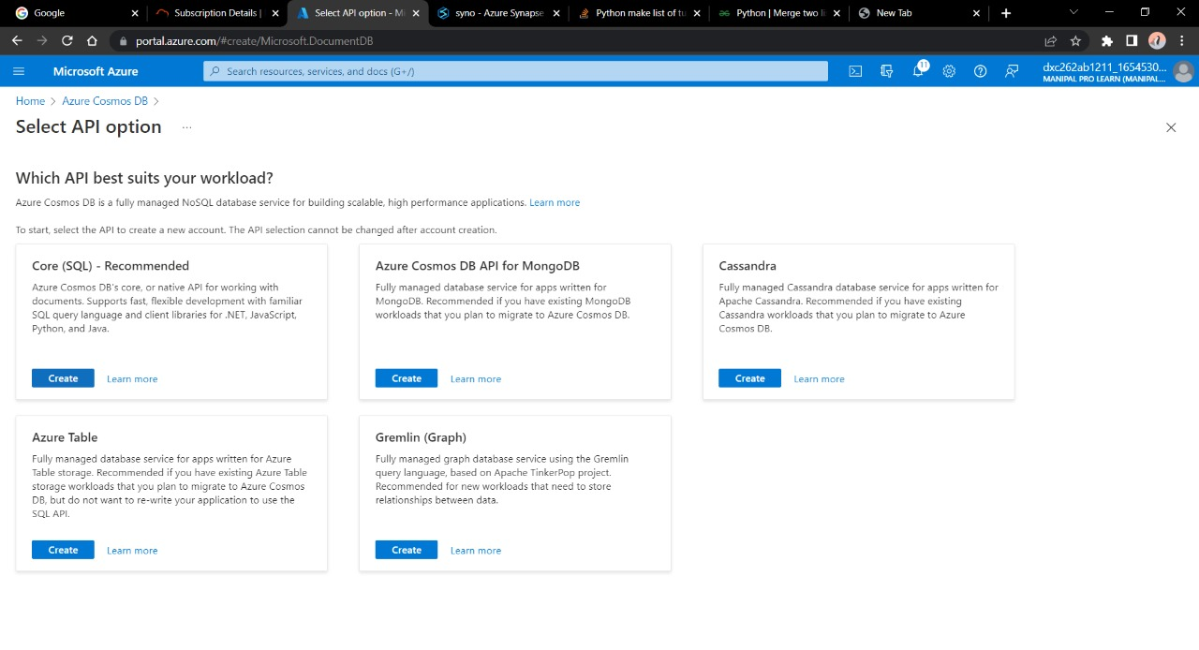

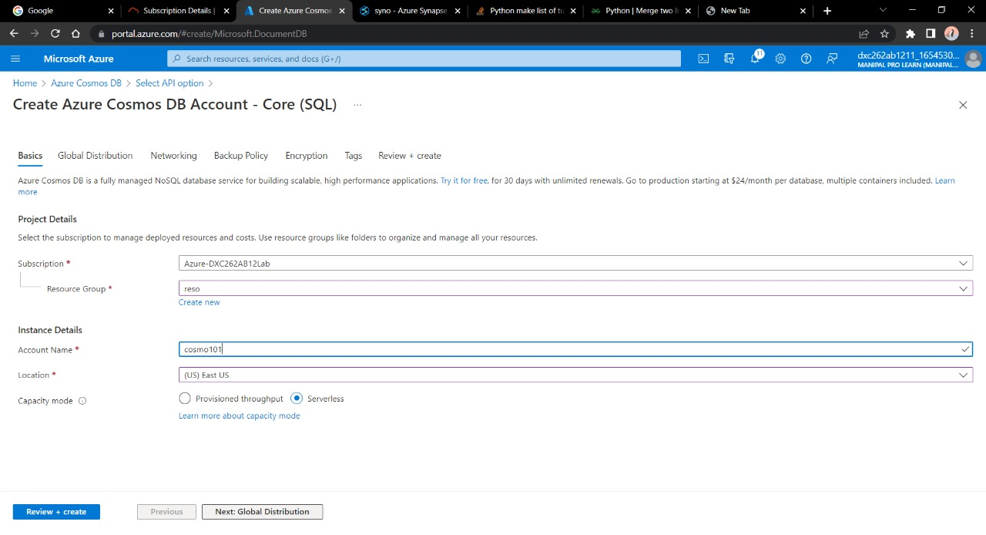

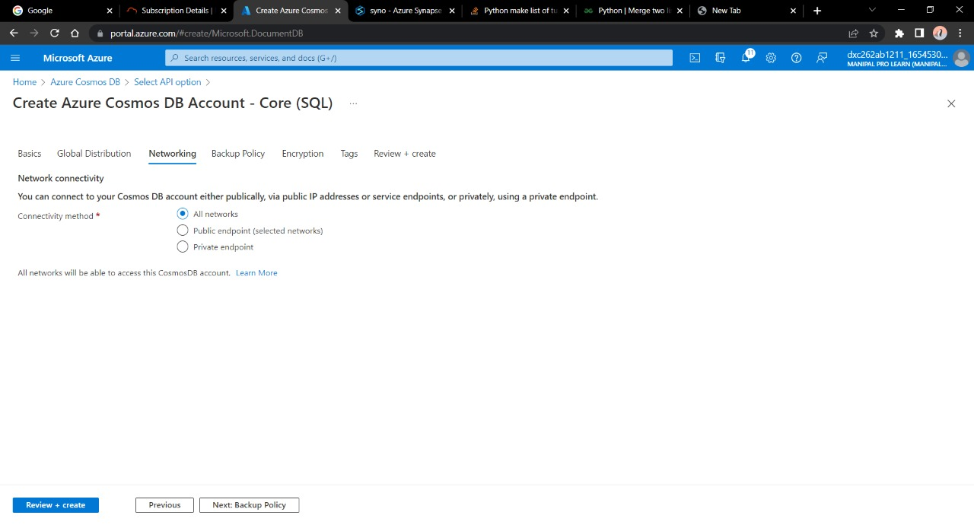

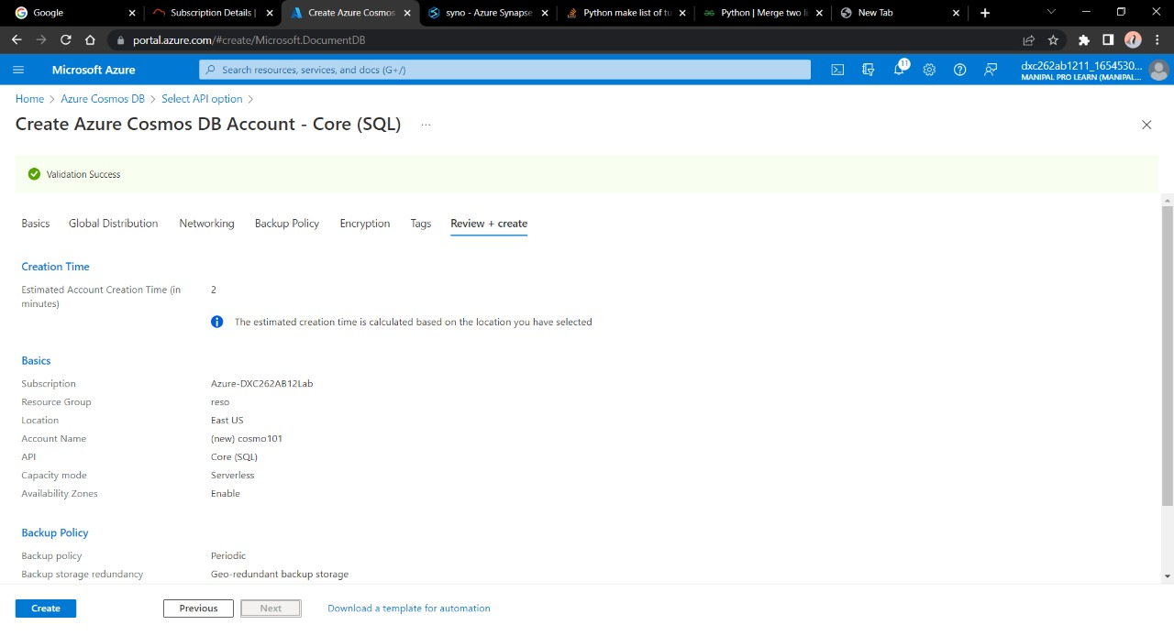

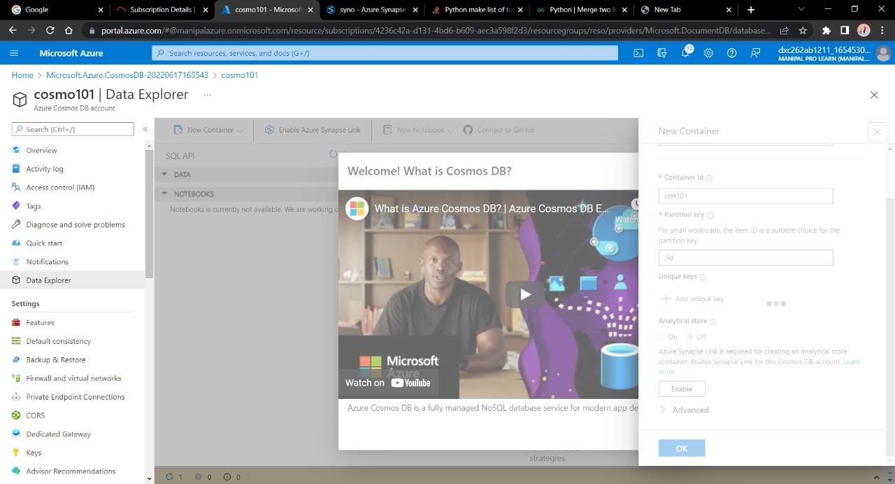

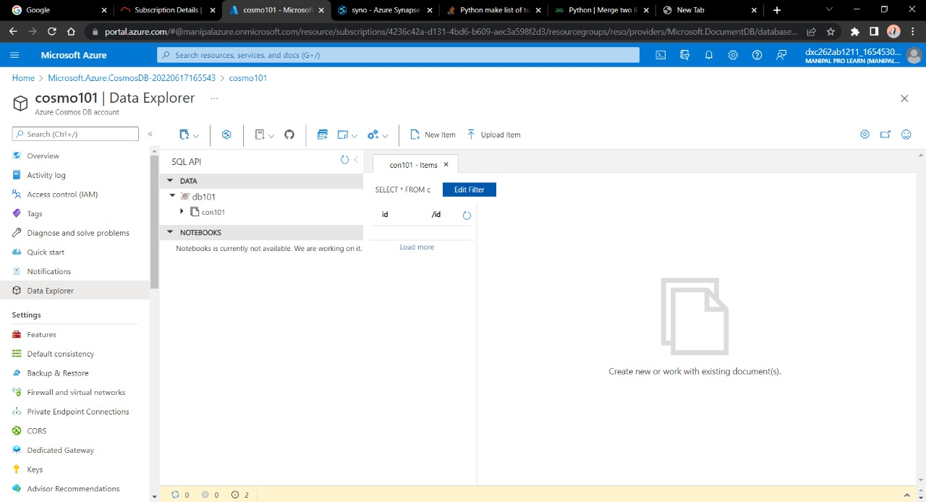

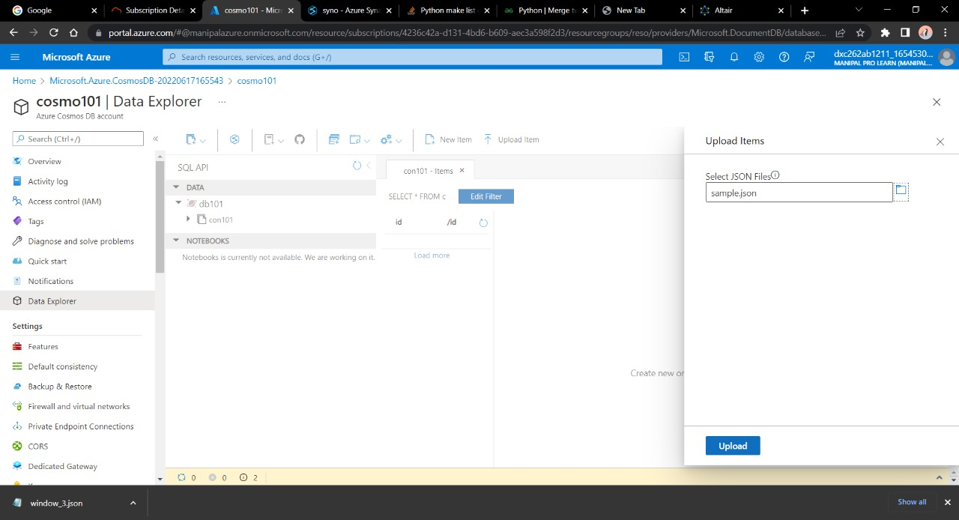

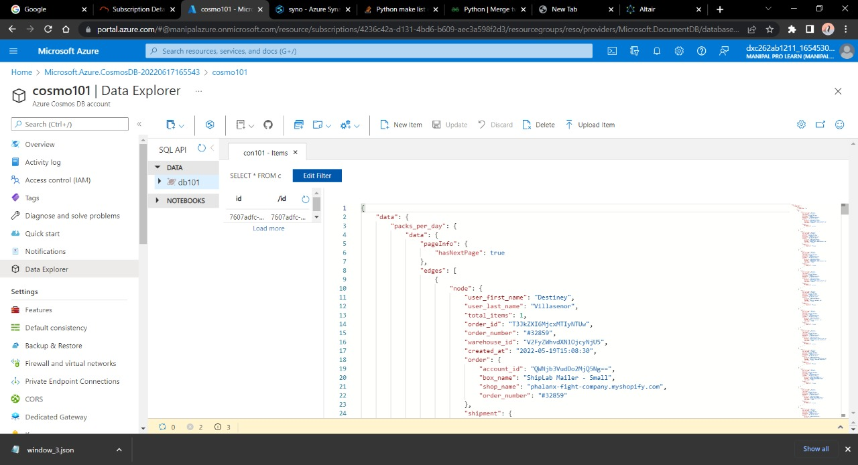

Now here we have successfully uploaded data into the Cosmos DB sql container.

7.Connect COSMOS DB & Azure Synapse analytics & explain the steps with screenshots.

Azure Synapse can be connected to Cosmos DB using the following steps. For this question we are going to use cosmos DB account and synapse account from previous answers and will try to connect them.

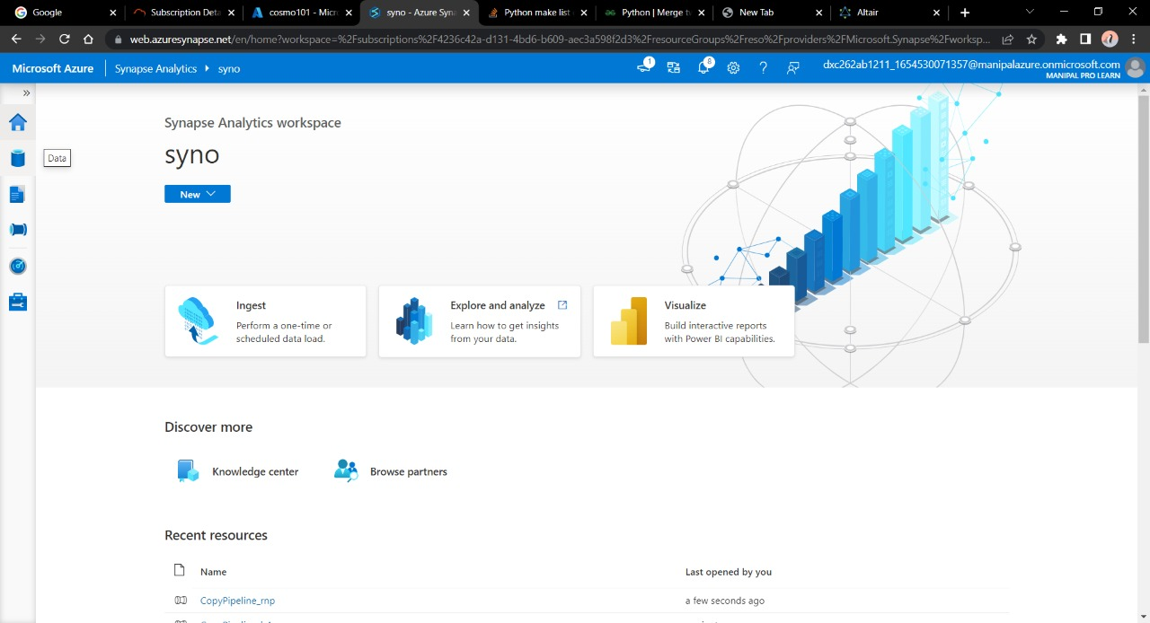

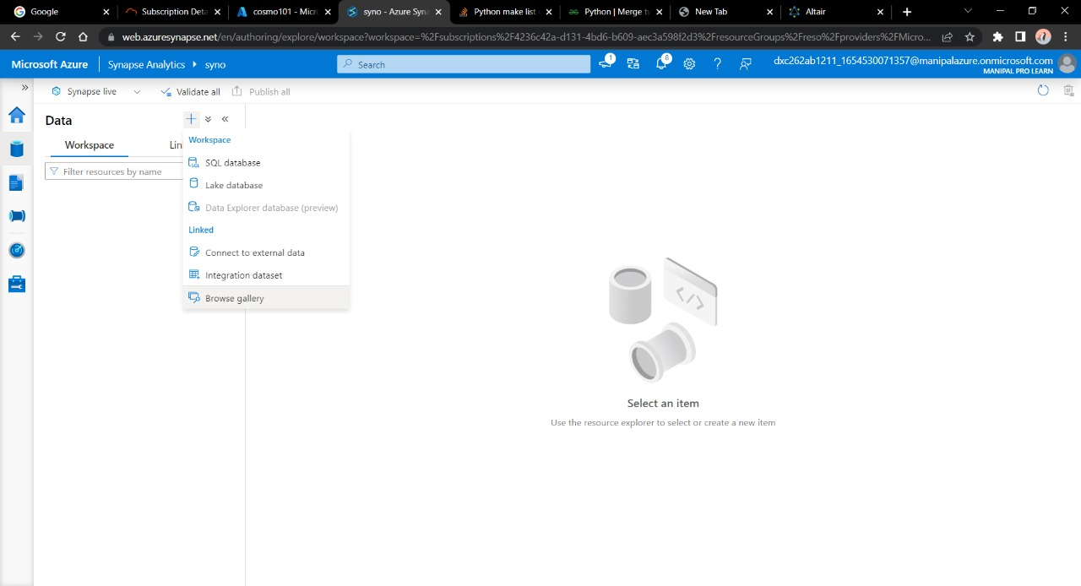

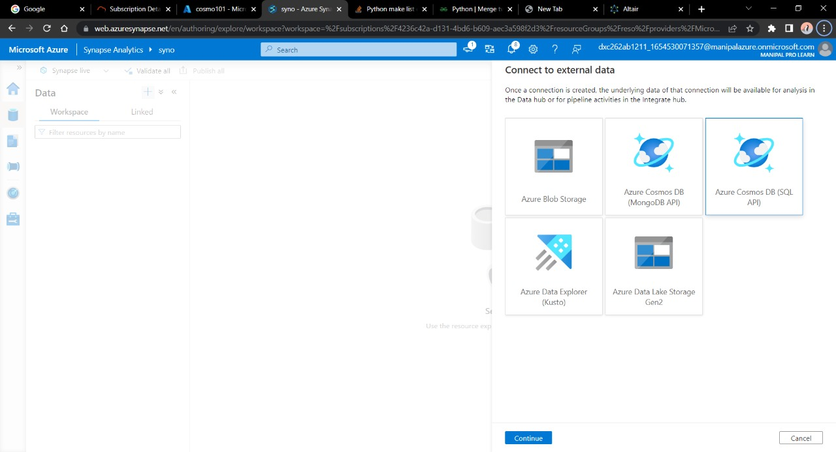

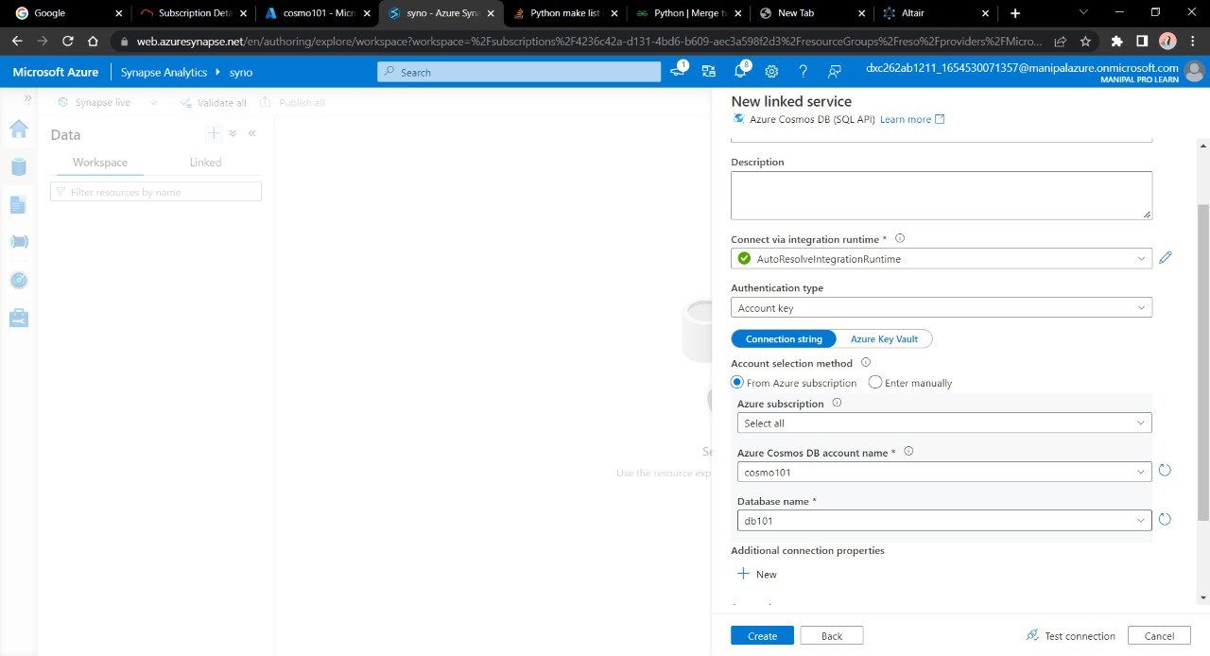

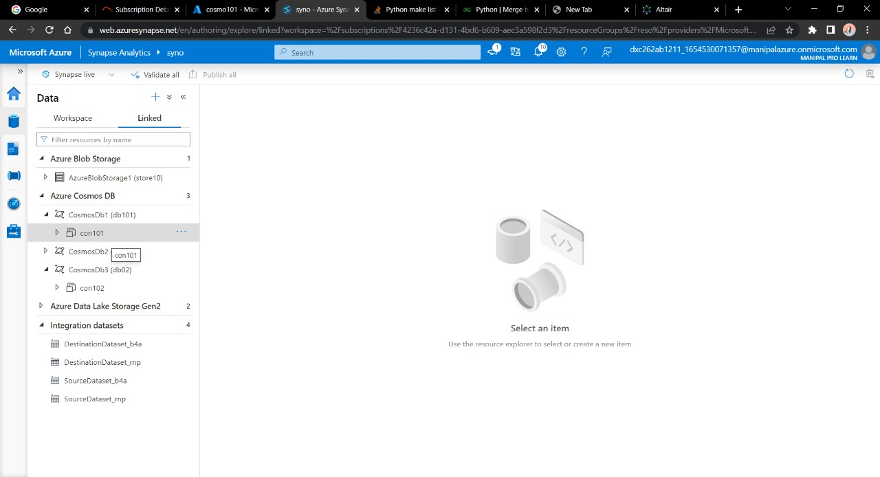

Here we have successfully loaded Cosmos DB sample json data into the Azure synapse lab.

8.Create azure Data factory & azure Blob, connect Blob & ADF,

import blob files into Data factory & explain the steps with screenshots

Azure Data Factory is a tool to integrate and to create data workflows. In order to connect blob storage with Azure data factory follow the steps below.

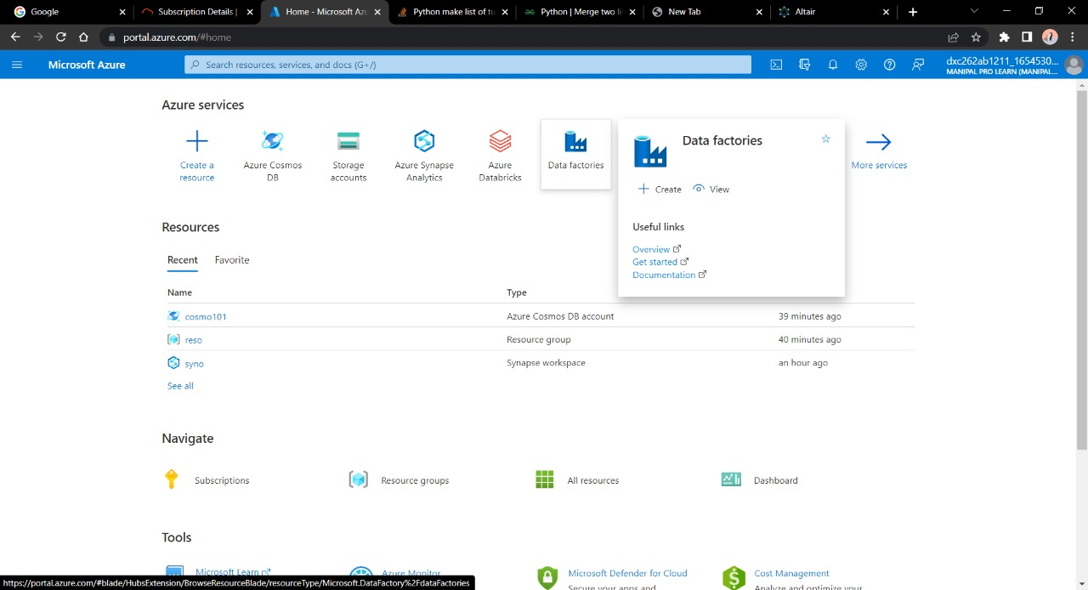

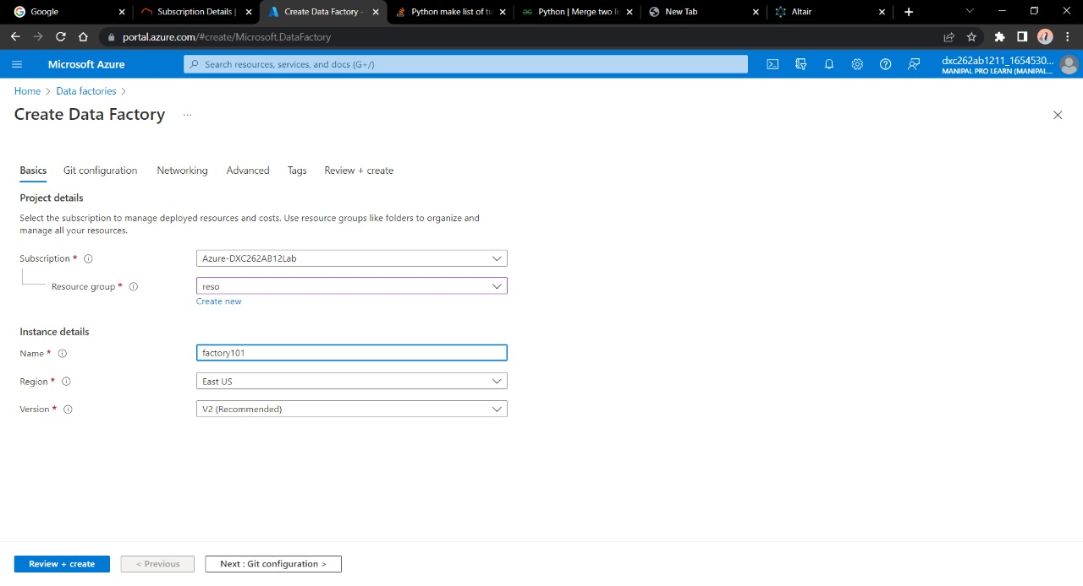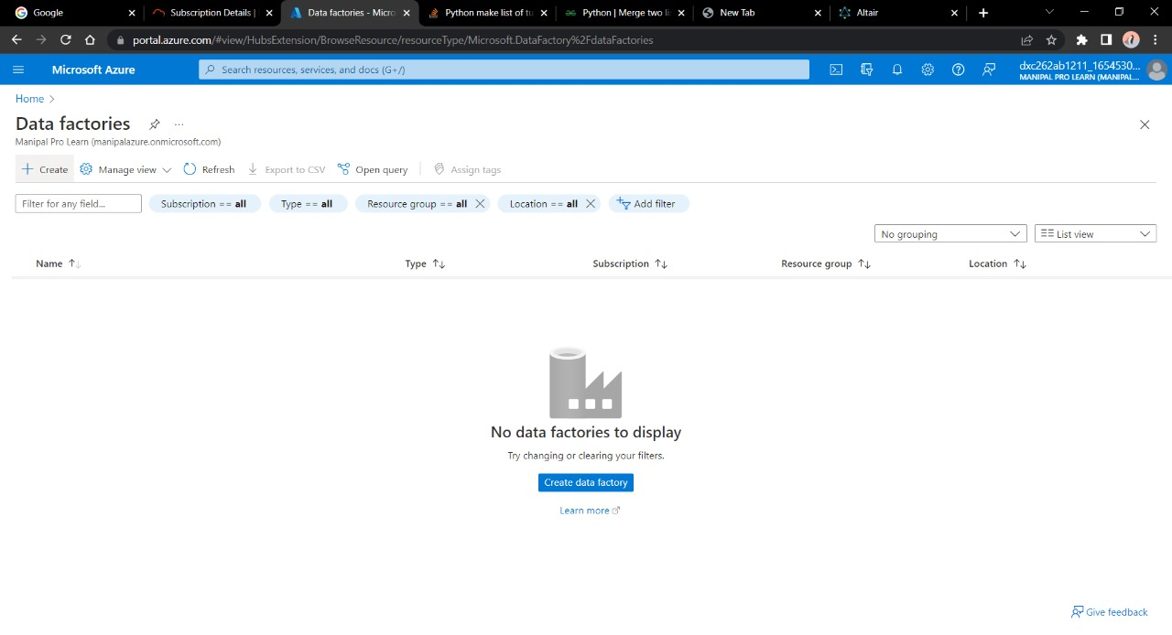

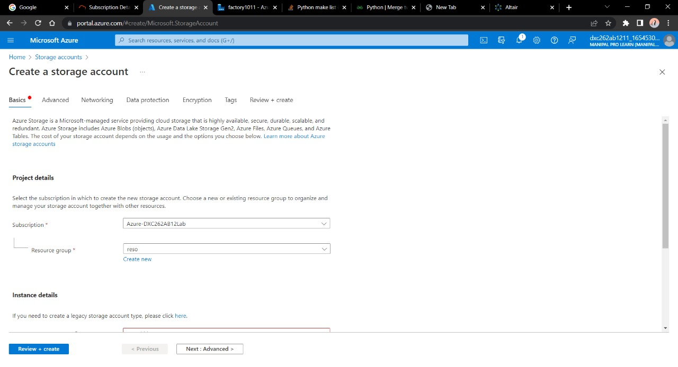

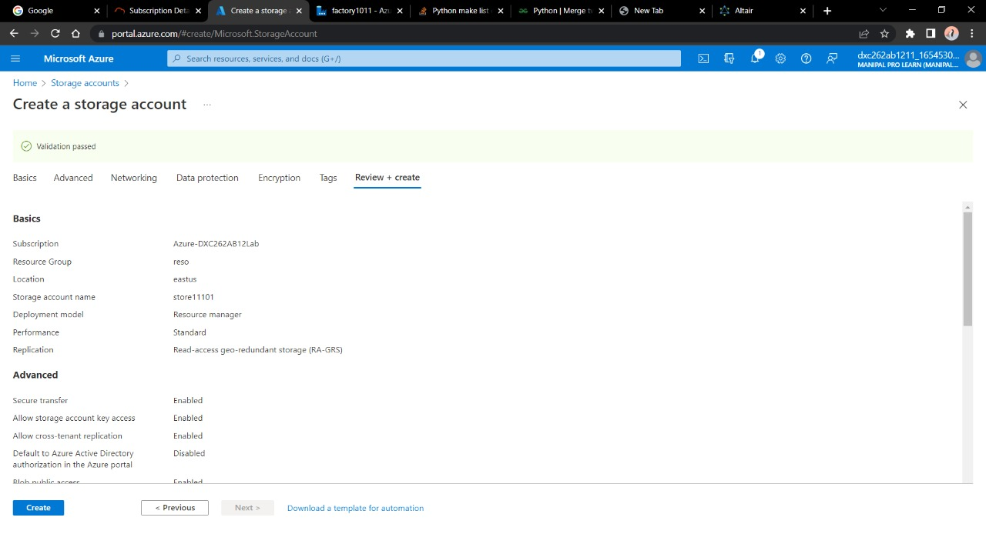

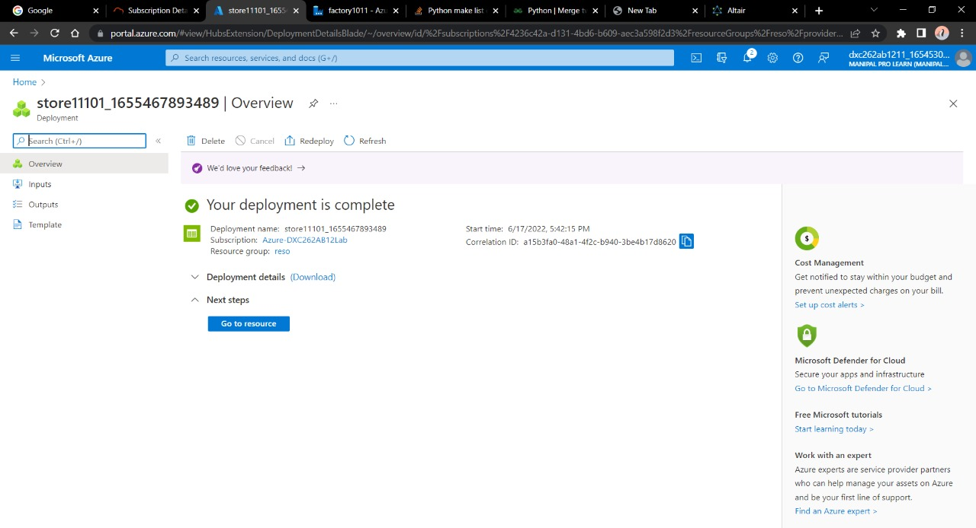

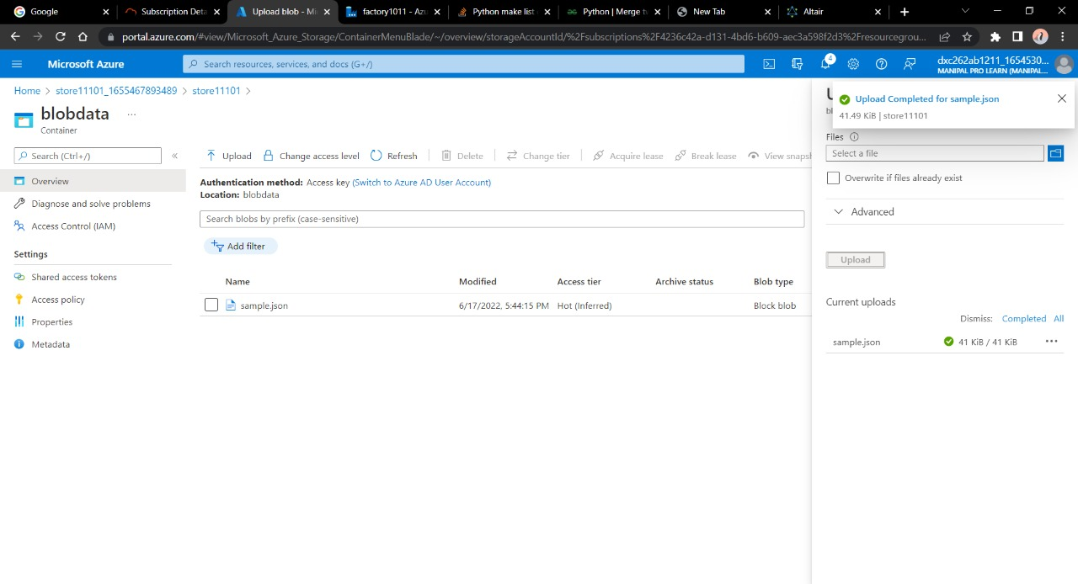

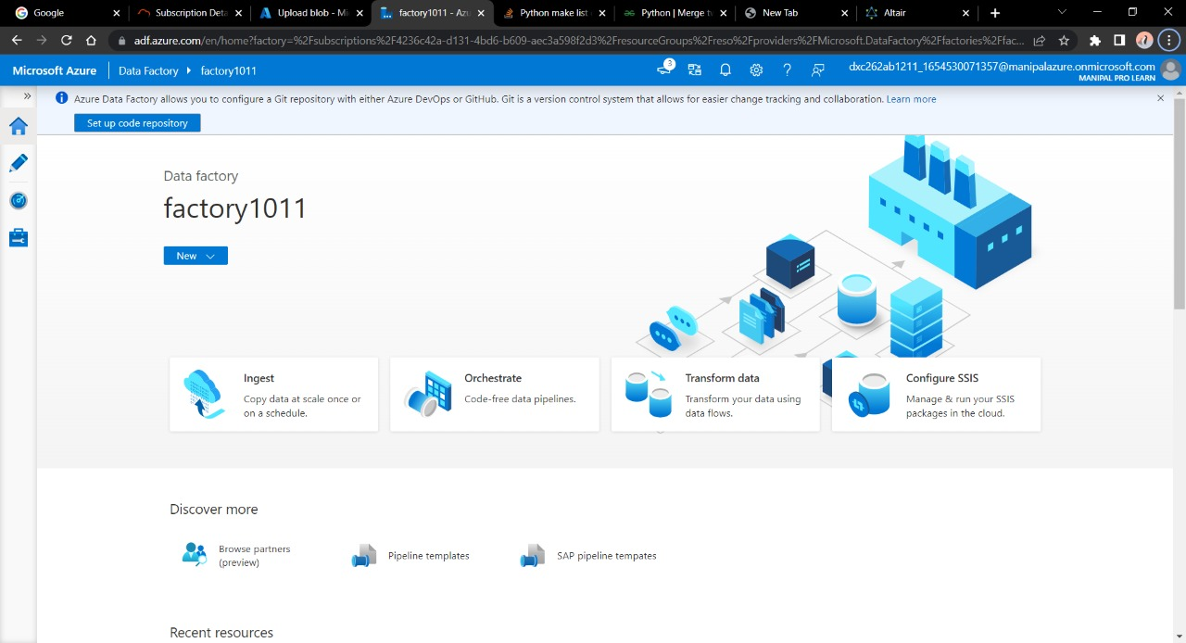

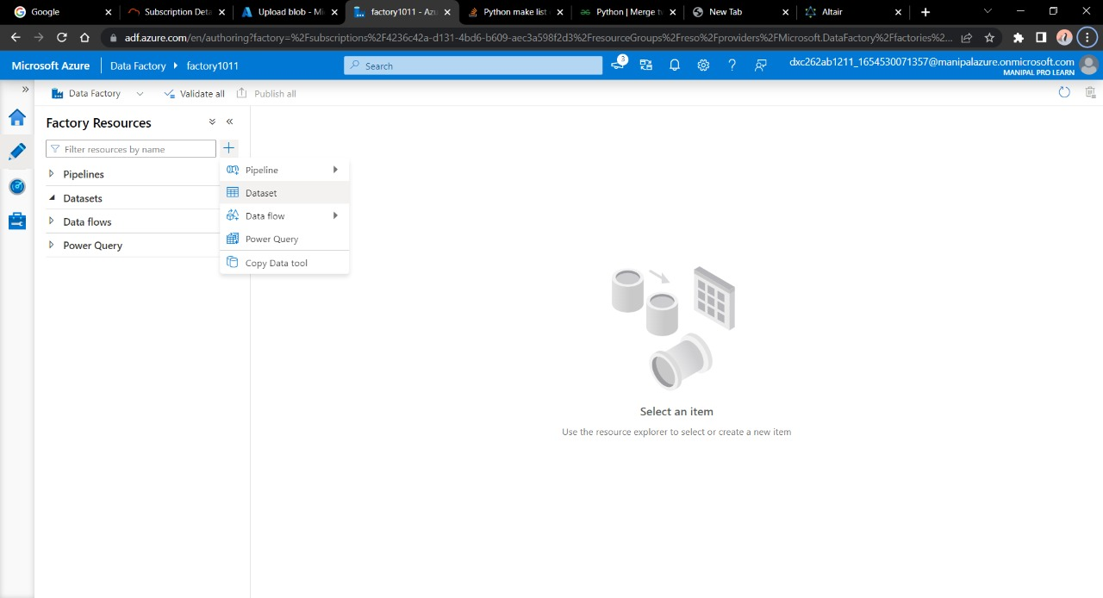

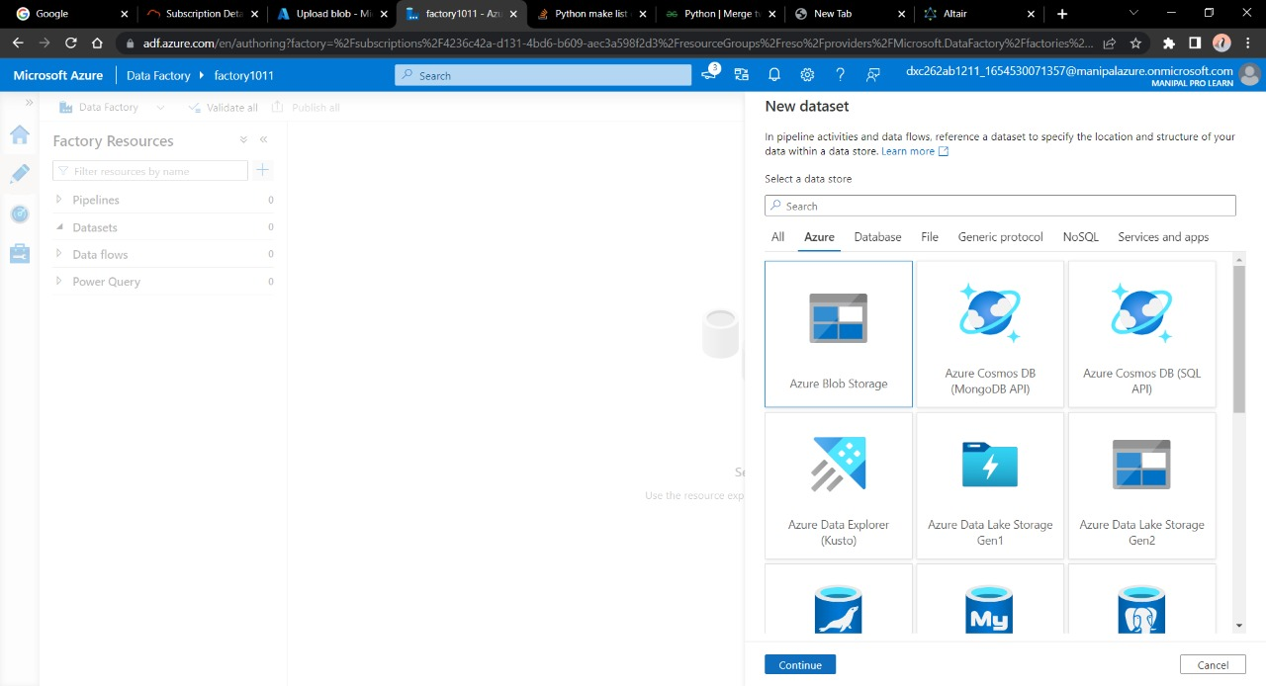

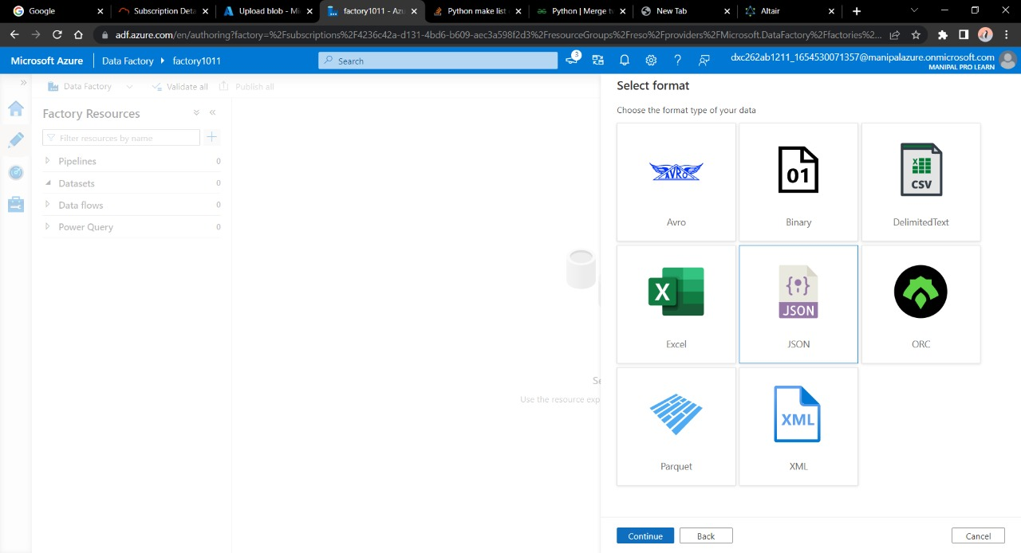

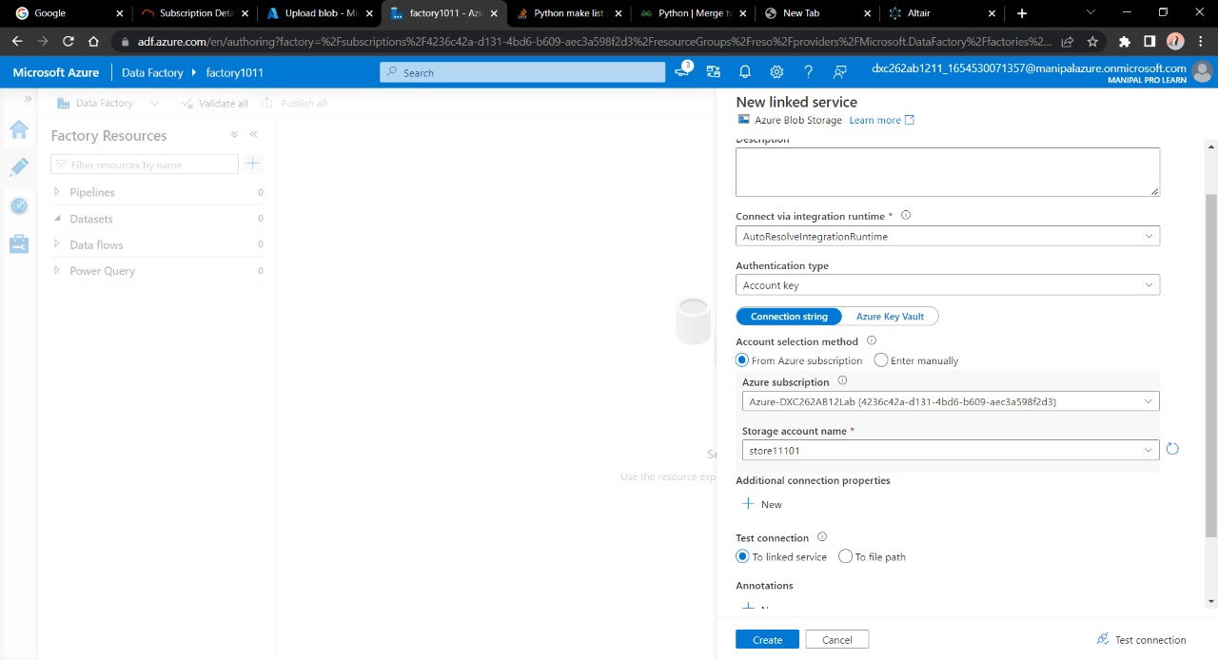

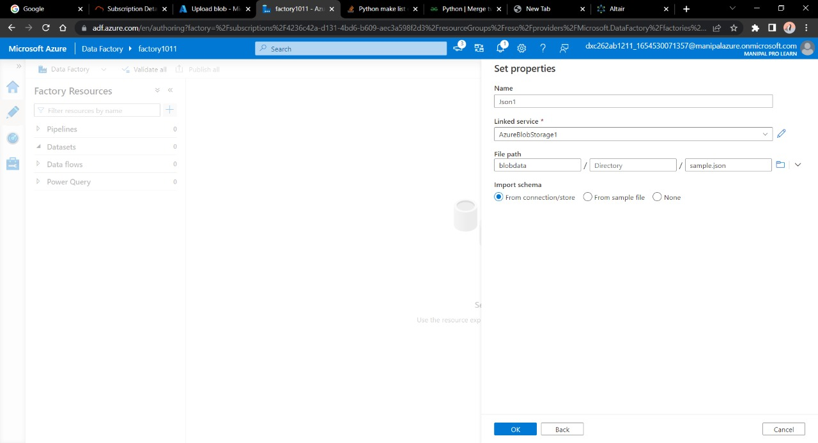

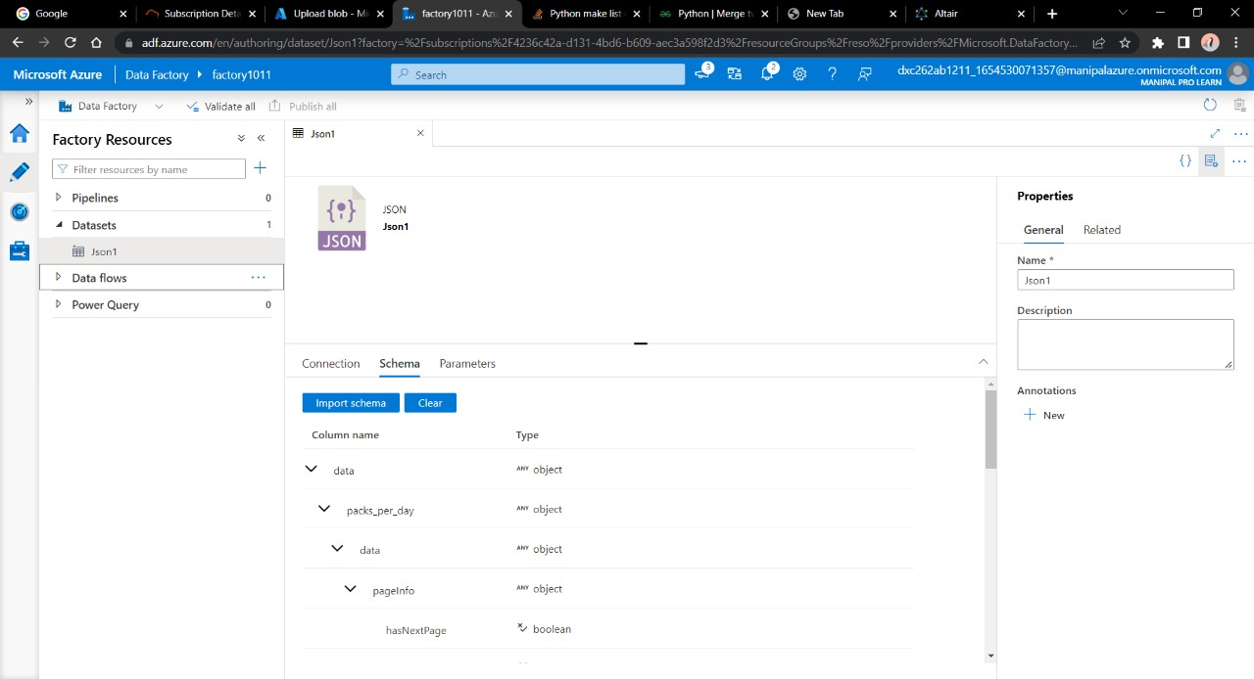

We have successfully created and linked a Azure data Factory and blob

storage & imported the data into the Azure data factory.